
AnyVolt
Features
2.5V to 24V output voltage range
4.2¹ to 28V recommended input voltage range
Extended mode operation down to 2.3V input
2A max input or output current
<100mV typical ripple at 2A out
Onboard voltage/current display
Input/output current limiting protection
Durable screw terminals to connect power / loads
Reverse input voltage protection
83% typical efficiency, up to 89%
No external components needed

General Description
The AnyVolt is an adjustable step up / step down 2A switching DC-DC converter. The output is adjustable from 2.5 to 24V.

The output voltage is set with a dial, similar to the volume control on a stereo system. Once the output voltage is set, it does not matter whether input voltage is higher, lower, or the same as the desired output.

AnyVolt has an on board 3 digit 7-segment display that can be toggled between showing output voltage or current.
Input power and output loads are connected with reusable screw terminals, so no soldering is necessary.
Additional circuitry ensures that the product won’t be damaged by reversed power connections, or by overloading.

Applications
Lab work and prototyping
Powering audio amplifiers
High voltage motors
Driving multiple LEDs in series
Backlit LCD drive
Solar powered applications
Battery powered applications
Renewable energy source applications
Universal battery charger
Low voltage doomsday devices

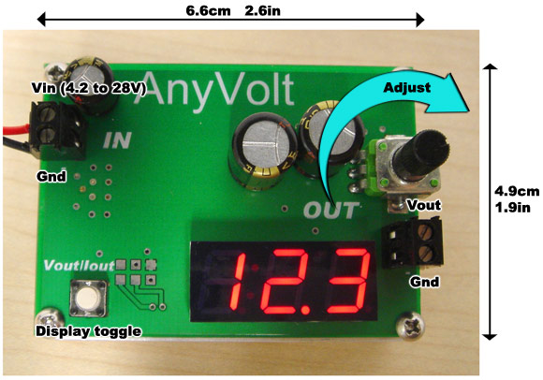

Specifications
Characteristic | Min | Typical | Max
Input Voltage | 2.5V ¹ | 4.2V to 24V | 28V
Output Voltage | 2.4V | 2.5V to 24V | <30V ²
Input Current (Continuous or Peak) |  |  | 2.0A
Output Current (Continuous or Peak) |  |  | 2.0A
Output Ripple (Vp-p) |  | 100mV | 200mV
Quiescent current draw | 9mA | 12mA | 45mA
Efficiency |  | 83% | 89%
Load Regulation |  | 1% | 4%³
Output Vp-p transient response to dynamic loads  (12V in, 18V out, 0.2A to 1A, 1ms pulses) |  | 1.5%

¹See section on extended mode operation
²Due to manufacturing variations, your AnyVolt will be able to reach outputs a little higher than 24V. If you get an AnyVolt that can output 27V, then congratulations! We only guarantee a 24V output though. Trying to continuously draw 2A at voltages above 24V is not recommended.
³Under prolonged heavy loading conditions excessive heat can cause the output voltage to drop by as much as 4%.
Proper usage guide
Antistatic precautions
As with all electronic equipment, please be careful to minimize touching of any electronic components on the circuit board. Before beginning work, you should ensure you have been grounded using an antistatic wrist band, or by touching a water faucet or a radiator. Please do not tempt fate by using an AnyVolt to power a Van-de-Graaf generator.

Heat precautions
During sustained use at high loads, the AnyVolt can become uncomfortably hot (60+ºC). While this will not cause damage to the AnyVolt, if you have sensitive skin, it can hurt you. As with all power electronics, please use caution.
Powering up the AnyVolt
Using a small flathead screwdriver, connect the wires from your input power source to the input side of the AnyVolt. The input terminal block(on the left) is labeled to have Vin + (Vcc) and Vin – (Gnd) sides, so you should connect power accordingly. Once power is correctly applied, the onboard display will start to display output voltage. It is usually a good idea to turn the output voltage down to the minimum before connecting the load, then turn it up later. This will prevent you from accidentally powering your load with a really high voltage if you forgot to turn the voltage back down the last time you used your AnyVolt.
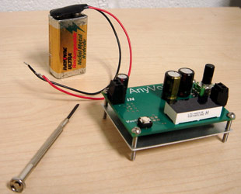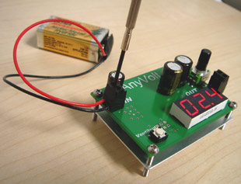

Adjusting the output voltage
Turning the voltage dial clockwise increases the voltage, similar to the volume control on a stereo system.

Connecting your project’s load
The output terminal block is on the right, and is labeled to have Vout + (Vout) and Vout – (Gnd) connections. Using a screwdriver, connect the power wires of your project to the appropriate terminals.

Note: The – (Gnd) terminals on the input and output are both connected within the AnyVolt. The AnyVolt is a non-isolated DC-DC converter, so you only really need 3 wires (Vin, Gnd, Vout) connected to the AnyVolt. Having a Gnd connection on both sides is merely an option for your convenience.

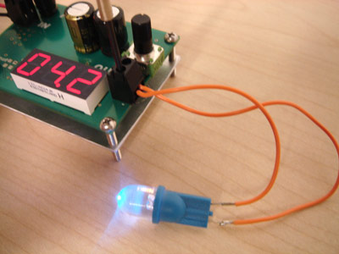
Connecting an LED to the output
It is extremely unlikely that you could ever hurt yourself with a 24V supply, but still use common sense and don’t do things like piercing your skin with the output wires.
Display
The AnyVolt has a 3 digit 7 segment display that displays either the output voltage or current at any given time. The voltage readout has resolution of 0.1V and typical accuracy of ±2%. The current readout has resolution of 0.1A and typical accuracy of ±5%. For projects requiring a higher degree of accuracy than this, such as precision A-D conversion, you should use a multimeter.

You can tell whether the display is showing current or voltage by the “A” denoting the number of Amps. Toggling the display is accomplished with the push switch on the AnyVolt.

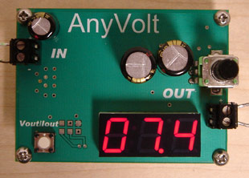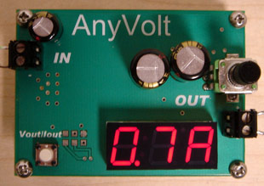
7.4V on the output 0.7A on the output
When too much current is going into or coming out of the AnyVolt, the display will flash “OC” (overcurrent) to warn you to reduce the load. See the overcurrent section for more details.

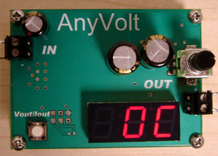
OverCurrent. Turn down the voltage!
Current limits
The output current of the AnyVolt can be displayed at the push of the button, so it is easy to see when it is approaching the 2A limit.

Input current however, is trickier to keep track of. If you are driving light loads of under 5W, you won’t need to worry about reaching the input current limit. If you are driving loads of well over 10W, then you might run into the problem of overcurrent if the input voltage is especially low. Since the AnyVolt isn’t able to violate laws of thermodynamics _{(yet)} , stepping up from a lower to a higher voltage means that there will be a higher current on the input than the output.
Example:
The output of the AnyVolt in a certain project is 19V, and it is supplying a constant 1A. What will the input current be if I am powering the AnyVolt with a 12V supply?
“Power = Volts * Amps”
19V*1A = 19W
So the power output is 19W.
“Output power / efficiency = Input power”
Looking at the efficiency curves of the AnyVolt datasheet, efficiency is about 83% in this situation.
19W / 0.83 = 22.89W
So the power going into the AnyVolt is 22.89W
“Power / Volts = Amps”
22.89W / 12V = 1.91A
So the current at the AnyVolt’s input is around 1.91A. This is barely under the limit for now, but if the input voltage supply were to drop significantly below 12V, the overcurrent condition would be reached.

Alternatively, you could just use a multimeter to check your input current and save your poor calculator’s overworked buttons from further abuse.

Overcurrent protection
When either of the input or output current limits of 2A have been exceeded, the AnyVolt’s voltage regulation controller will shut off and the output voltage will drop to zero. The AnyVolt will remain in shut-down mode for 1-2 seconds. During this time “OC” (overcurrent) will be displayed. It will then start up again and try resume normal operation. The AnyVolt will continue to start/stop in short bursts until the excess load has been removed. While this is effective in protecting the AnyVolt from damage, you should still be careful to not overload the AnyVolt because the on/off switching will certainly not help powering your project.
Keep in mind the display only shows output current, so if you see OC flashing when you are only drawing 1.5A at the output, it means you are trying to draw more than 2A from a lower voltage supply at the input.

Extended mode operation
The AnyVolt is capable of operating below its minimum recommended input voltage of 4.2V. This will not damage the AnyVolt, but it will limit its functionality. For example, at loads well under 1A, the onboard display will start to give incorrect readings, and the output voltage range will be limited.

However, very low voltage mode operation can be useful in certain projects. With low enough loads, you can still step voltage up to much higher values and still power useful projects. This table should help you get an idea of what the AnyVolt can do with very low voltage inputs.

Input voltage | Max load before display loses all reliability | Max load at 12V out | Max load at 24V out
4.0V | 300mA | 350mA | 150mA
3.3V | 100mA | 150mA | 100mA
2.8V | Display unreliable | 90mA | 40mA
2.5V | Display unreliable | 40mA | 20mA
2.3V | Display unreliable | 20mA | 9mA

If the display is deemed unreliable, you should use a multimeter to measure input / output voltage and current. Over-current protection does not work unless the display is also working correctly so be careful to not overload anything!

Noises from the AnyVolt
Under certain low-load conditions, a faint, high pitched whine or hissing noise can be heard from the AnyVolt during operation. This is normal, harmless, and not an indication that the product is faulty. In order to deliver a low ripple output at low loads, the AnyVolt’s switching controller enters pulse skipping mode. While the normal switching frequency of the AnyVolt is much higher than the human hearing range, when the controller enters pulse skip mode, audible harmonics of the switching frequency can sometimes be heard.
Efficiency Curves

