
AnyVolt Micro
Features
2.6V to 14V output voltage range
2.6V to 14V input voltage range
0.5A max input or output current at 10V
<50mV typical ripple
No external components needed
Weighs 3 grams
Thermal protection
Overcurrent protection and short circuit protection

General Description
The AnyVolt Micro is a miniature step up / step down switching DC-DC converter. The output is adjustable from 2.6 to 14V.
The output voltage is set with a small screw potentiometer on the side of the AnyVolt Micro. Once the output voltage is set, it does not matter whether the input voltage is higher, lower, or the same as the desired output.

The AnyVolt Micro is pin-compatible with the common 78XX series of linear voltage regulators, so it will work with breadboards and other popular prototyping methods.

Applications
Lab work and prototyping
Powering small audio amplifiers
Driving multiple LEDs in series
Backlit LCD drive
Solar powered applications
Remote video transmitters
Battery powered applications
Renewable energy source applications
Powering things from two AA batteries

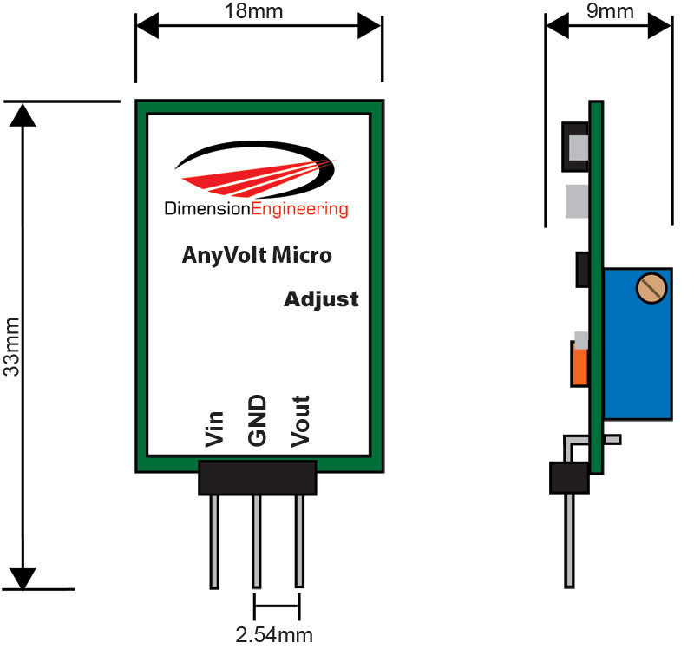

Characteristic | Min | Typical | Max
Input Voltage | 2.5V | 2.6V to 12V | 14V
Output Voltage | 2.5V | 2.6V to 14V | 15.5V¹
Continuous Input Current |  |  | 0.5A²
Continuous Output Current |  |  | 0.5A²
Output Ripple (Vp-p) | 15mV | 40mV | 160mV
Quiescent current draw | 6mA | 15mA | 32mA³
Efficiency |  | 75% | 77%
Recommended ambient temperature range | -20ºC | 25ºC | 55ºC⁴

¹Max output varies with manufacturing processes.
² The 0.5A rating is for input and output voltages under 10V. For 10V and above, please see the tables later on in the datasheet.
³2.6V in, 14V out
⁴Ambient temperatures higher than room temperature will decrease the amount of current AnyVolt Micro can handle. For optimal performance, mount AnyVolt Micro in an open space with air flowing across it.

Adjusting the output voltage
With the adjustment screw facing you, turning it clockwise increases the voltage, similar to the volume control on a stereo system.

Current limits
Input and output current to/from the AnyVolt Micro should be kept track of with a multimeter if you anticipate driving heavy loads.

Stepping up from a lower to a higher voltage means that there will be a higher current on the input than the output. For this reason, it is important to make sure that both the input and output current limits of 0.5A aren’t being exceeded. If for some reason you cannot use a multimeter to monitor input current, you can also implicitly derive the input current using the input voltage, output voltage, and output current.
Example:
The output of the AnyVolt Micro in a certain project is 12V, and it is supplying a constant 150mA. What will the input current be if I am powering the AnyVolt Micro with a 5V supply?
“Power = Volts * Amps”
12V*0.15A = 1.8W
So the power output is 1.8W.
“Output power / efficiency = Input power”
Looking at the efficiency curves of the AnyVolt Micro datasheet, efficiency is about 75% in this situation.
1.8W / 0.75 = 2.4W
So the power going into the AnyVolt Micro is 2.4W
“Power / Volts = Amps”
2.4W / 5V = 0.48A
So the current at the AnyVolt Micro’s input is around 0.48A. This is within limits for now, but if the input voltage supply were to drop significantly below 5V, the overcurrent condition would be reached.
Here is a table of typical max loads you can power with an AnyVolt Micro, depending on your input voltage.

3.3V in
Output Voltage (V) | 3 | 4 | 5 | 6 | 7 | 8 | 9 | 10 | 11 | 12 | 13 | 14
Max current out (mA) | 413 | 310 | 248 | 207 | 177 | 155 | 137 | 124 | 113 | 103 | 96 | 89
5V in
Output Voltage (V) | 3 | 4 | 5 | 6 | 7 | 8 | 9 | 10 | 11 | 12 | 13 | 14
Max current out (mA) | 500 | 467 | 375 | 313 | 268 | 234 | 208 | 188 | 171 | 156 | 145 | 134
9V in
Output Voltage (V) | 3 | 4 | 5 | 6 | 7 | 8 | 9 | 10 | 11 | 12 | 13 | 14
Max current out (mA) | 500 | 500 | 500 | 500 | 442 | 422 | 375 | 338 | 309 | 281 | 260 | 241
12V in
Output Voltage (V) | 3 | 4 | 5 | 6 | 7 | 8 | 9 | 10 | 11 | 12 | 13 | 14
Max current out (mA) | 500 | 500 | 500 | 500 | 500 | 500 | 500 | 450 | 410 | 375 | 346 | 321

Overcurrent/overtemperature behavior
If the current limit has been considerably exceeded, or if the device is overheated to beyond 85ºC the AnyVolt Micro will gradually reduce the output voltage in an attempt to reduce the load on the device. Once the extra load is removed or the temperature is brought down, the desired output voltage will be restored. It is unlikely that you will destroy an AnyVolt Micro by exceeding the current/temperature ratings but we still recommend practicing good engineering techniques and do not overload the device beyond the recommended operating parameters.

Additional notes
AnyVolt Micro uses a 25 turn worm gear driven potentiometer and cannot wiggle loose. Do not apply glue to the voltage adjustment pot.

AnyVolt Micro should be mounted at least 2 inches away from any circuitry that is sensitive to RF.
For best performance, mount AnyVolt Micro in an open space with some air flowing across it to keep it cool.
Efficiency Curves

