
AnyVolt Mini
Features
1.25V to 14V output voltage range
3.3V to 14V recommended input voltage range
Extended mode operation down to 2.8V input
0.5A max input or output current
0.75A peak input or output current
<50mV typical ripple at 0.5A out
No external components needed
80% typical efficiency, up to 84%

General Description
The AnyVolt Mini is the little brother of the AnyVolt. It is a miniature step up / step down 0.5A switching DC-DC converter. The output is adjustable from 1.25 to 14V.
The output voltage is set with a small screw potentiometer on the side of the AnyVolt Mini. Once the output voltage is set, it does not matter whether input voltage is higher, lower, or the same as the desired output.

The AnyVolt Mini is pin-compatible with the common 78XX series of linear voltage regulators, so it will work with breadboards and other popular prototyping methods.

Applications
Lab work and prototyping
Powering small audio amplifiers
Driving multiple LEDs in series
Backlit LCD drive
Solar powered applications
High power crystal based radio transmitters
Battery powered applications
Renewable energy source applications
Universal battery charger

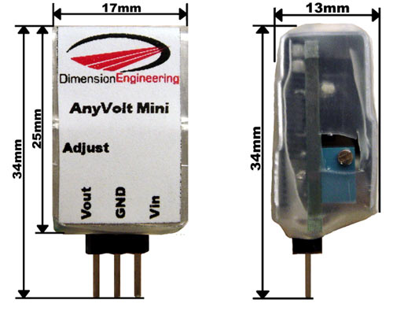

Characteristic | Min | Typical | Max
Input Voltage | 2.8V ¹ | 3.3V to 12V | 14V
Output Voltage | 1.25V | 1.25V to 14V | 15.5V ²
Continuous Input Current |  |  | 0.5A
Peak Input Current (30 sec) |  |  | 0.75A
Continuous Output Current |  |  | 0.5A
Peak Output Current (30 sec) |  |  | 0.75A
Output Ripple (Vp-p) | 18mV | 30mV | 200mV
Quiescent current draw | <1mA | 10mA | 32mA³
Efficiency |  | 80% | 84%

¹See section on extended mode operation.
²Max output varies with manufacturing processes.
³3.3V in, 14V out

Adjusting the output voltage
With the adjustment screw facing you, turning it clockwise increases the voltage, similar to the volume control on a stereo system.

Current limits
Input and output current to/from the AnyVolt Mini should be kept track of with a multimeter if you anticipate driving heavy loads.

Stepping up from a lower to a higher voltage means that there will be a higher current on the input than the output. For this reason, it is important to make sure that both the input and output current limits of 0.5A aren’t being exceeded. If for some reason you cannot use a multimeter to monitor input current, you can also implicitly derive the input current using the input voltage, output voltage, and output current.
Example:
The output of the AnyVolt Mini in a certain project is 12V, and it is supplying a constant 150mA. What will the input current be if I am powering the AnyVolt with a 5V supply?
“Power = Volts * Amps”
12V*0.15A = 1.8W
So the power output is 1.8W.
“Output power / efficiency = Input power”
Looking at the efficiency curves of the AnyVolt datasheet, efficiency is about 77% in this situation.
1.8W / 0.77 = 2.34W
So the power going into the AnyVolt Mini is 2.34W
“Power / Volts = Amps”
2.34W / 5V = 0.47A
So the current at the AnyVolt’s input is around 0.47A. This is within limits for now, but if the input voltage supply were to drop significantly below 5V, the overcurrent condition would be reached.

Overcurrent behaviour
After the 0.5A current limit has been considerably exceeded, the AnyVolt Mini will start to reduce the output voltage in an attempt to reduce the load on the device. However, the AnyVolt Mini never shuts down. The result of this is that under exceptionally heavy (>.8A) loads, the ‘Mini is not able to perform the necessary limiting and will overheat and possibly fail. The AnyVolt Mini cannot tolerate a short circuited output for more than 20 seconds.

Extended mode operation
The AnyVolt Mini is capable of operating below its minimum recommended input voltage of 3.3V. This will not damage the ‘Mini, but you must be aware that efficiency drops drastically beyond this point to under 50%. The output voltage can also start dropping well before the 500mA limit is reached. For example, at 2.8V in, the max load with 6V out is 50mA. At 12V out the max is 39mA. With low enough loads, you can still step voltage up to much higher values and still power useful devices.
Additional notes
The AnyVolt Mini uses an 11 turn worm gear driven potentiometer and cannot wiggle loose. Do not apply glue to the adjustment pot.
Efficiency Curves

