Installation:
CellShield installs in a few easy steps.

Step 1: Unplug the ESC from your receiver and plug the CellShield’s RCVR pigtail into the receiver’s throttle port. | Step 2: Plug the ESC’s throttle connector into the ESC port on CellShield
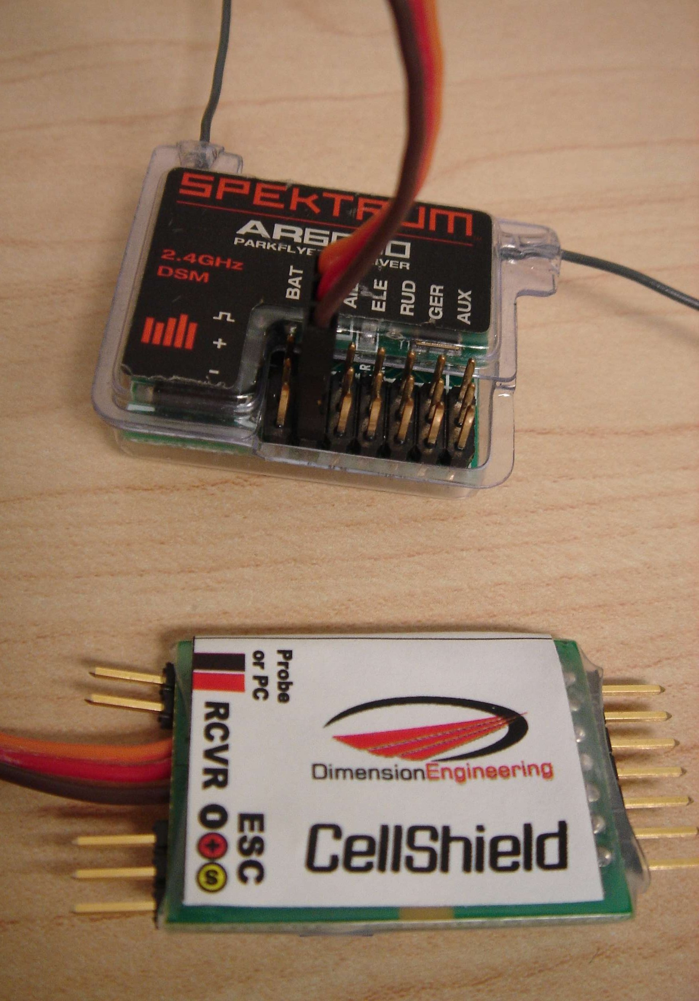 | 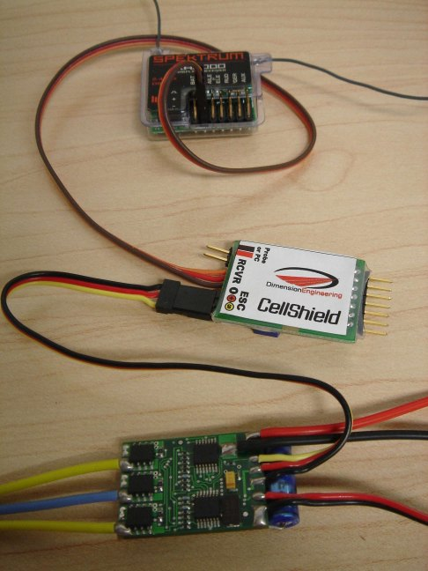
Step 3: When you are ready to fly, connect the battery to the ESC. | Step 4: Connect CellShield’s Battery port to the battery’s tap connector. CellShield will detect the battery and light the LEDs corresponding to each cell.
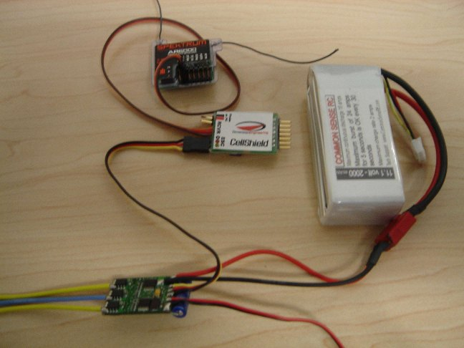 | 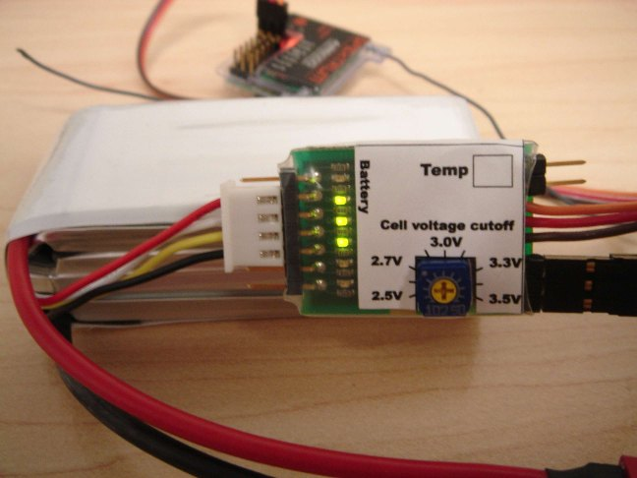

Please note that CellShield requires a throttle signal to perform its battery detection. If the green LEDs do not turn on, check that the transmitter and receiver are both powered up.

Adjusting the cutoff voltage:

CellShield’s cutoff voltage is adjustable from 2.5v to 3.5v per cell. This adjustment is done via the blue potentiometer using a small Phillips screwdriver. CellShield ships set with a 3.0v/cell cutoff voltage. There is a small arrow molded into the dial which points to the voltage setting.
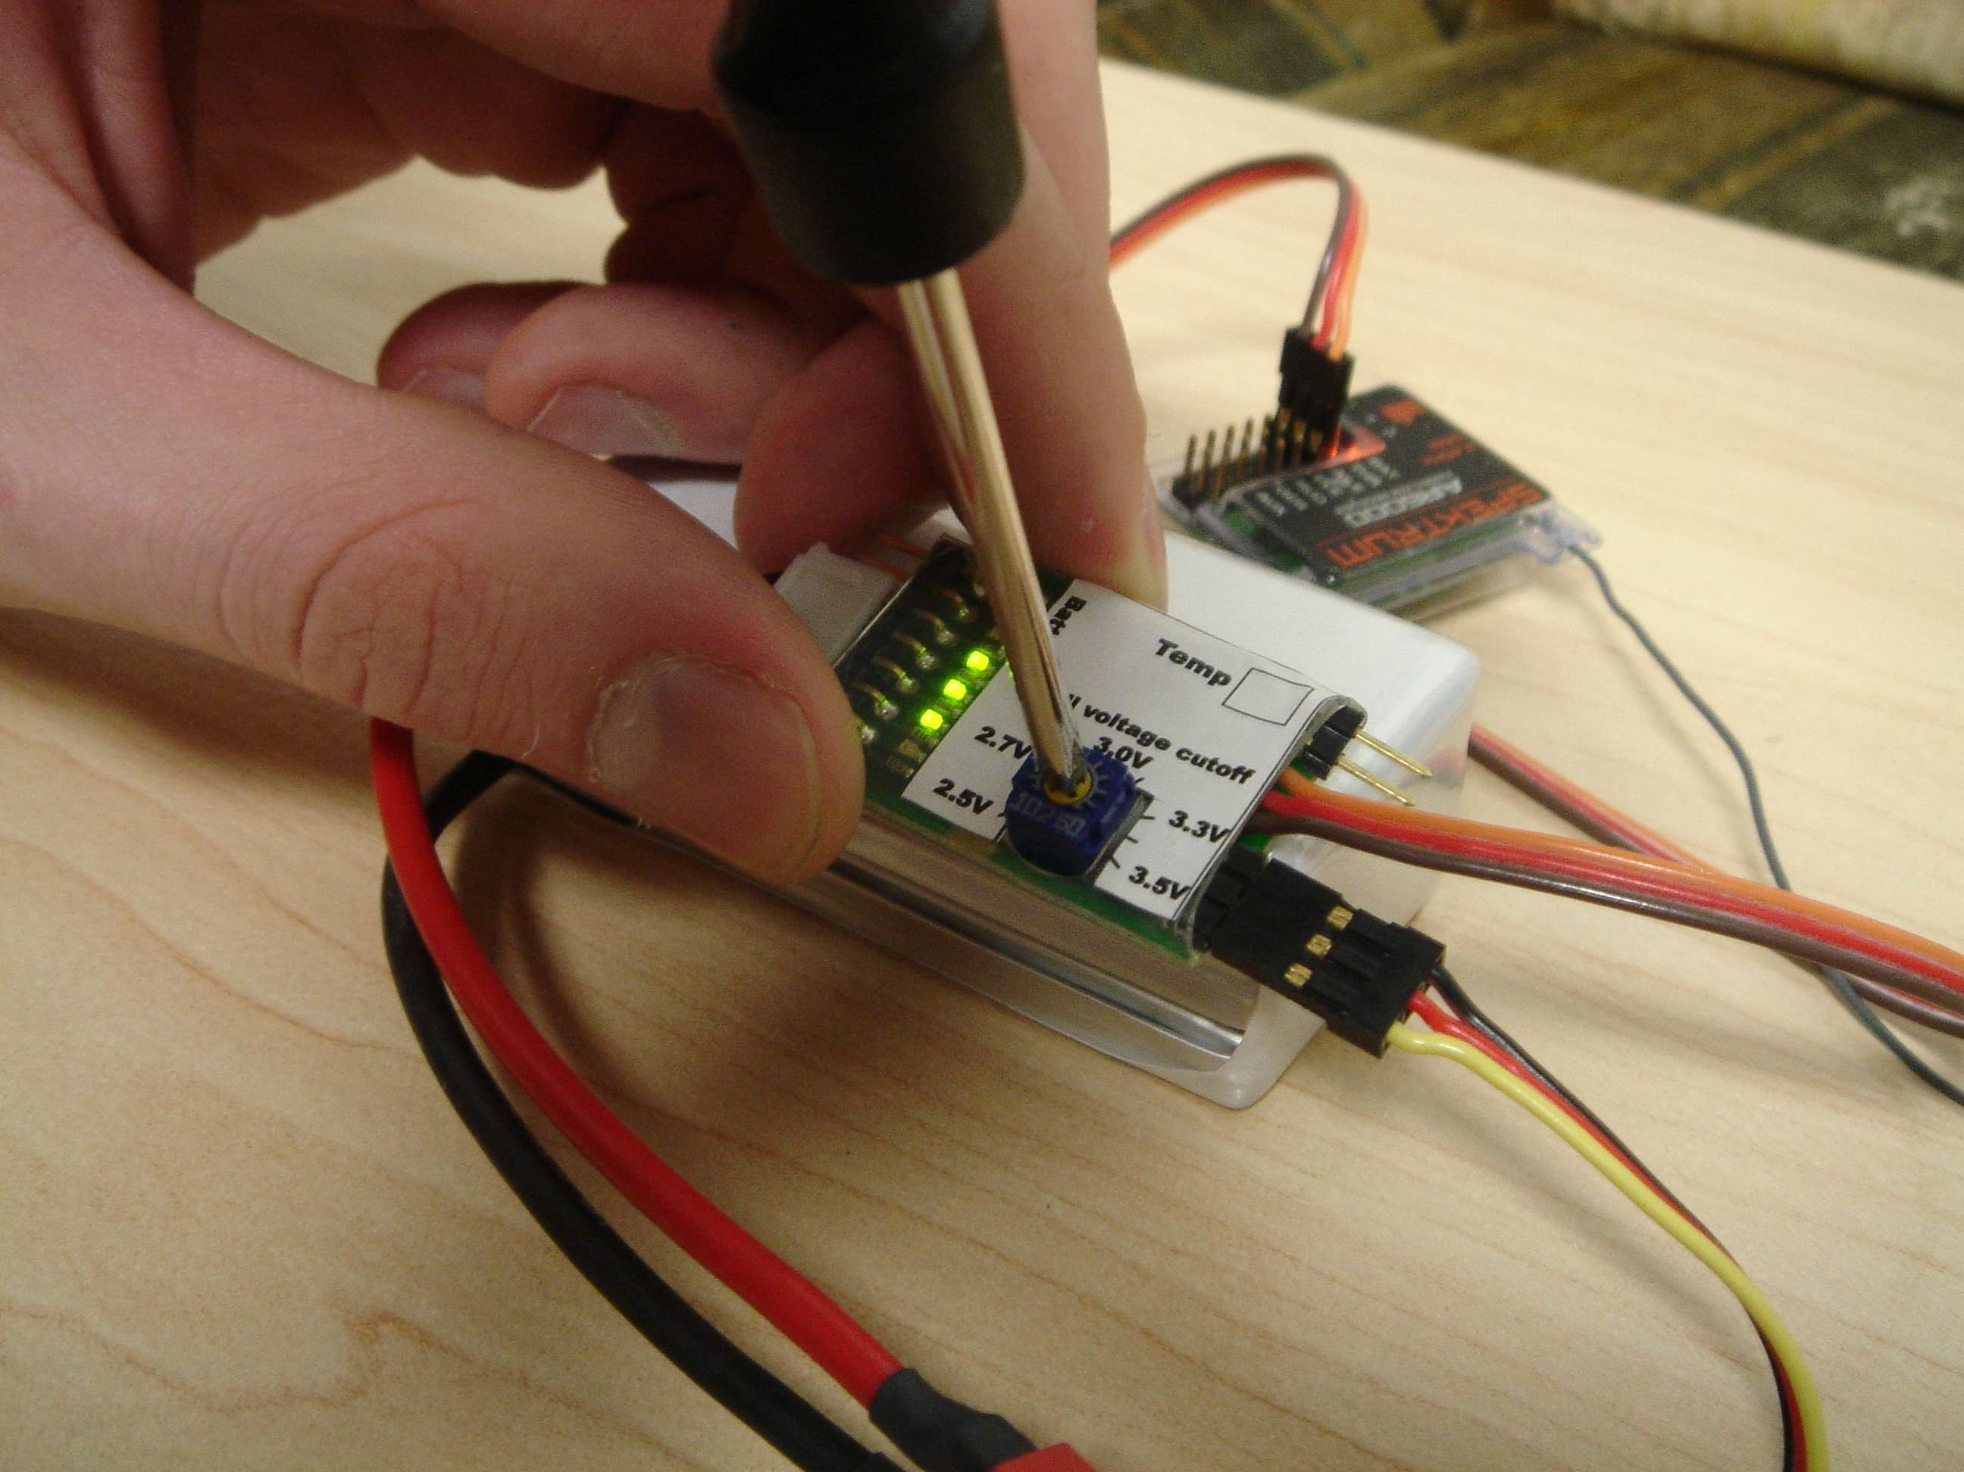

Optional Thermal probe:

The optional thermal probes will provide a cutoff when the battery is in danger of damage due to overheating. Thermal probes install into the Probe or PC port

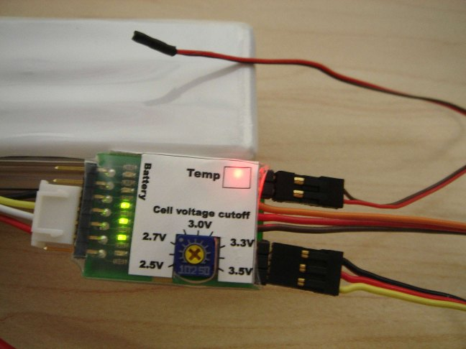

When a thermal probe is detected, the red Temp LED will light. If the CellShield has detected a temperature above 150 degrees Fahrenheit, the Temp LED will flash until power is removed. When a temperature of more than 150 degrees is encountered, CellShield will reduce the throttle setting to reduce the battery temp. If the temperature remains above 150 degrees, CellShield will gradually cut off throttle.

The thermal probes are removable, so they may be permanently attached to the battery if desired.
