
DE-ACCM2G Buffered ±2g Accelerometer
Features
Dual axis ±2g sense range
Up to 750mV/g sensitivity
500Hz bandwidth
Operating voltage 3 to 5V
Reverse voltage protection
Overvoltage protected up to 14V
Output short protection
Standard DIP-14 form factor
Integrated power supply decoupling
Draws under 2mA
<4% typical 0g bias deviation from Vcc/2
Shiny gold pins to distract the enemy!

General Description
The DE-ACCM2G is an off the shelf 2 axis 2g accelerometer solution with analog outputs. It features integrated op amp buffers for direct connection to a microcontroller’s analog inputs, or for driving heavier loads.

Additional circuitry ensures that the product won’t be damaged by reversed power connections, or voltages above the recommended ratings.

The DE-ACCM2G is designed to fit the DIP-14 form factor, making it suitable for breadboarding, perfboarding, and insertion into standard chip sockets.

It is based on the Analog Devices ADXL322 for superior sensitivity and lower cost.

Applications
Motion, tilt and slope measurement
Shock sensing
Vehicle acceleration logging

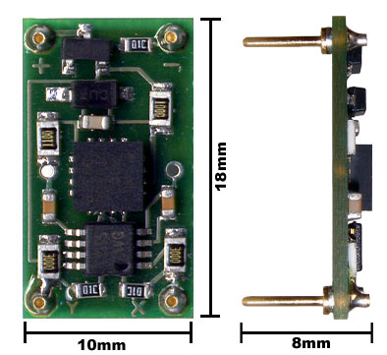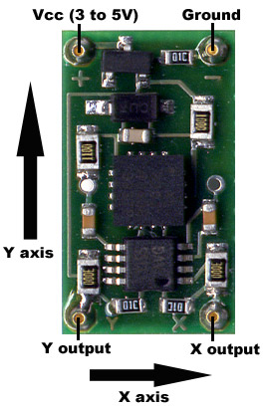

Measuring acceleration and tilt
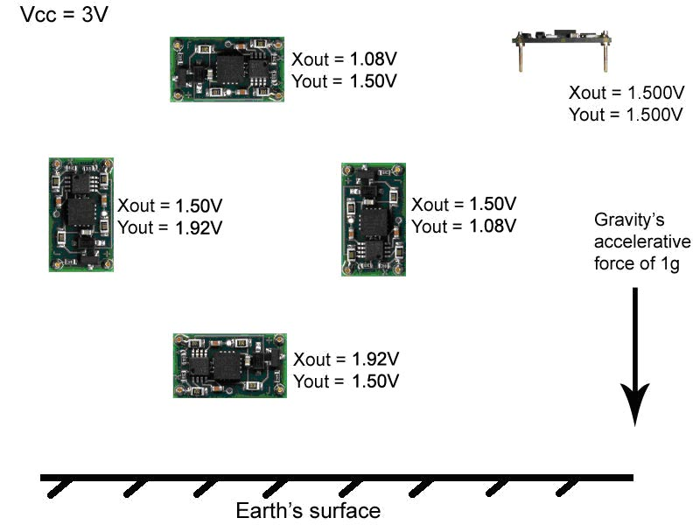
The voltage outputs on the DE-ACCM2G correspond to acceleration being experienced in the X and Y directions. The output is ratiometric, so the output sensitivity (in mV/g) will depend on the supply voltage. When supplied with 5V, sensitivity is typically 750mV/g. At 3V, sensitivity drops to 420mV/g. Zero acceleration (0g) will result in an output of Vcc/2 regardless of the voltage supplied to the unit.
Due to manufacturing variances when Analog Devices makes their accelerometer chips, these values aren’t always set in stone. They can vary by up to 5% in extreme cases, including the 0g bias point. For projects that require a very high degree of accuracy, we recommend that you incorporate measured calibrations into your hardware/software.
Voltage to acceleration example:
”With a 5V supply, the X output reads 3.06V. What acceleration does this correspond to?”
At 5V, the 0g point is approximately Vcc / 2 = 5.00 / 2 = 2.50V
3.06V - 2.50V = +0.56V with respect to the 0g point
At 5V, if sensitivity is 750mV/g, 0.56 / 0.750 = 0.747g
Therefore the acceleration in the X direction is +0.747g
Acceleration to voltage example:
”I am powering the DE-ACCM2G with 3V. What voltage will correspond to an acceleration of -0.5g?”
At 3V, the 0g point is approximately 1.50V
If sensitivity at 3V is 420mV/g, -0.5 * 0.420 = -0.21V with respect to the 0g point.
1.50V – 0.21V = 1.29V
Therefore you can expect a voltage of approximately 1.29V when experiencing an acceleration of -0.5g.

Voltage to tilt example:
“With a Vcc of 3V, and the accelerometer oriented flat and parallel to ground in my robot, Yout is 1.500V. When my robot goes uphill, Yout increases to 1.582V. What is the slope of the hill?”
1.582V – 1.500 = +0.082V with respect to the 0g point.
With a sensitivity of 420mV/g, 0.082 / 0.420 = 0.195g
Sin⁻¹(0.195) = 11.2º
The slope of the hill is 11.2º in the Y axis

Tilt to voltage example:
“I am making an antitheft device that will sound an alarm if it is tilted more than 30º with respect to ground in any direction. I have measured the 0g bias point to be 2.521V, and I want to know what voltage to trigger the alarm at. I am using a 5V source.”
Sin(30º) = 0.5 so acceleration with a tilt of 30º will be 0.5g
0.5g * 0.750V/g = 0.375V with respect to the 0g point
2.521 + 0.375 = 2.896V
2.521 – 0.375 = 2.146V
Sound the alarm when the voltage reaches more than 2.896V or less than 2.146V.
Performance features
Output buffers
A bare accelerometer chip has an output impedance of 32kΩ, which is unsuitable for obtaining reliable measurements when connected to an analog to digital converter. On the DE-ACCM2G, a dual rail to rail operational amplifier buffers the outputs from the ADXL322, greatly reducing output impedance.
→ Buffer loading characteristics
For the purposes of this section, “max load” is defined as the resistive load that will cause a 2mV drop in the output voltage at 0g. If your application does not require this level of accuracy, the DE-ACCM2G can supply even more current at the cost of a larger drop in output voltage.

Max load at Vcc of 5v is 0.83mA, or a resistance of 3kΩ
Max load at Vcc of 3v is 0.50mA, or a resistance of 3kΩ

Supply filtering
A pair of resistors and a 0.1uF ceramic bypass capacitor on the DE-ACCM2G provide excellent power supply decoupling. No external capacitors are necessary between Vcc and GND.
Output filtering and noise
A pair of 10nF capacitors limit the noise figure of the DE-ACCM2G, without overly sacrificing bandwidth. RMS noise is typically 6.2mg, and output bandwidth is 500Hz - making it suitable for high frequency sampling of acceleration.
Protection features
Overvoltage up to 14V
During prototyping, a common mistake is to power a device without checking the voltage output of one’s bench supply first. To ensure the ADXL322 chip on a DE-ACCM2G won’t get damaged by this, a zener diode in parallel with the ADXL322’s power pins clamps the voltage supplied to a maximum of 5.6V. This is not intended to be a long-term voltage regulation solution. Do not run the DE-ACCM2G at more than its recommended input voltage of 3-5V for more than 5 minutes at a time!
It is important to note that the X and Y outputs remain unclamped, i.e. 0g still corresponds to Vcc/2 . So if one accidentally powers a DE-ACCM2G with 14V, the outputs would read 7v or more, which might be enough to damage an external device connected at the time.

Reverse voltage
Even the best engineers sometimes get their wires crossed. In the event that you mix up VCC and GND, a P channel MOSFET will prevent current from flowing – protecting the DE-ACCM2G from damage. This protection is only designed to work with DC voltages. Do not apply AC voltages to the power pins.

Improper insertion
A resistor network ensures that the DE-ACCM2G will not be permanently damaged if you insert it backwards (i.e. apply power to the output pins). The product will not function properly while it is used backwards. Do not leave the DE-ACCM2G inserted backwards for more than 5 minutes at a time.
Output shorting
The operational amplifier driving the DE-ACCM2G’s outputs is capable of handling a direct short from the X and Y outputs to ground for as long as you want.

