
DE-ACCM2G2 Buffered ±2g Accelerometer
Features
Dual axis ±2g sense range
660mV/g sensitivity
500Hz bandwidth
Operating voltage 3.5V to 15V (onboard regulator)
Reverse voltage protection
Overvoltage protected up to 14V
Output short protection
Standard DIP-14 form factor
Integrated power supply decoupling
Draws under 2mA
<4% typical 0g bias deviation from Vcc/2
Shiny gold pins to distract the enemy!

General Description
The DE-ACCM2G2 is an off the shelf 2 axis 2g accelerometer solution with analog outputs. It features integrated op amp buffers for direct connection to a microcontroller’s analog inputs, or for driving heavier loads.

Additional circuitry ensures that the product won’t be damaged by reversed power connections, or voltages above the recommended ratings.

The DE-ACCM2G2 is designed to fit the DIP-14 form factor, making it suitable for breadboarding, perfboarding, and insertion into standard chip sockets.

It is based on the ST MicroElectronics LIS244ALH for superior sensitivity and lower cost.

Applications
Motion, tilt and slope measurement
Shock sensing
Vehicle acceleration logging

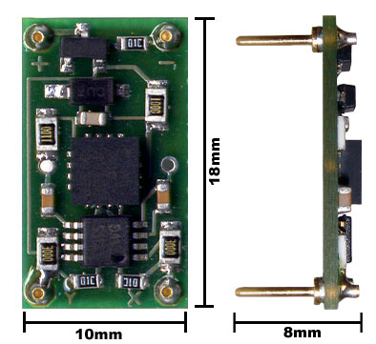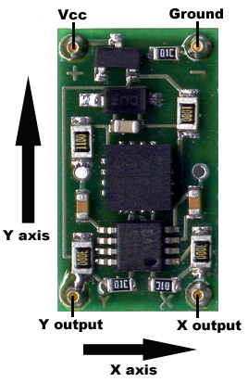

Measuring acceleration and tilt
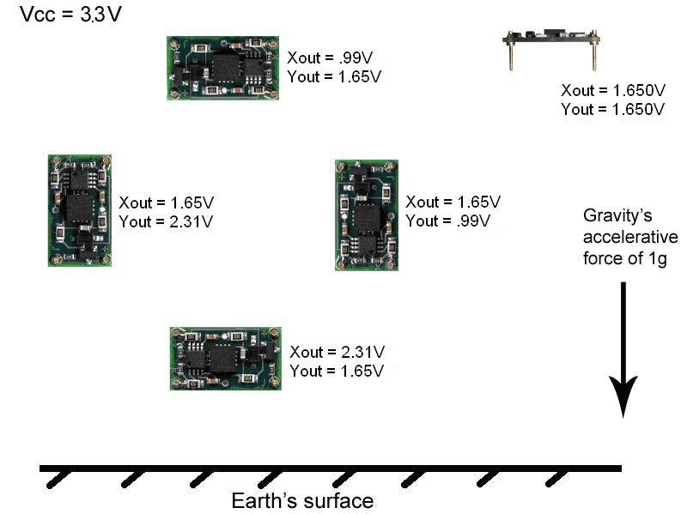
The voltage outputs on the DE-ACCM2G correspond to acceleration being experienced in the X and Y directions. The output is ratiometric, so the output sensitivity (in mV/g) depends on the supply voltage. The onboard regulator of the DE-ACCM2G2 keeps a constant 3.3V, making sensitivity a consistent 660mV/g.

Zero acceleration (0g) will result in an output of Vcc/2.
Due to manufacturing variances when ST Microelectronics makes their accelerometer chips, these values aren’t always set in stone. They can vary by up to 5% in extreme cases, including the 0g bias point. For projects that require a very high degree of accuracy, we recommend that you incorporate measured calibrations into your hardware/software.
Voltage to acceleration example:
”The X output reads 2.14V. What acceleration does this correspond to?”
The 0g point is approximately Vcc / 2 = 3.3 / 2 = 1.65V
2.14V – 1.65V = +0.49V with respect to the 0g point
If sensitivity is 660mV/g, 0.49 / 0.660 = 0.742g
Therefore the acceleration in the X direction is +0.742g
Acceleration to voltage example:
”What voltage will correspond to an acceleration of -0.5g?”
The 0g point is approximately 1.65V
If sensitivity is 660mV/g, -0.5 * 0.660 = -0.33V with respect to the 0g point.
1.65V – 0.33V = 1.32V
Therefore you can expect a voltage of approximately 1.32V when experiencing an acceleration of -0.5g.

Voltage to tilt example:
“With the accelerometer oriented flat and parallel to ground in my robot, Yout is 1.650V. When my robot goes uphill, Yout increases to 1.779V. What is the slope of the hill?”
1.779V – 1.650 = +0.129V with respect to the 0g point.
With a sensitivity of 660mV/g, 0.129 / 0.660 = 0.195g
Sin⁻¹(0.195) = 11.2º
The slope of the hill is 11.2º in the Y axis

Tilt to voltage example:
“I am making an antitheft device that will sound an alarm if it is tilted more than 30º with respect to ground in any direction. I have measured the 0g bias point to be 1.682V, and I want to know what voltage to trigger the alarm at.”
Sin(30º) = 0.5 so acceleration with a tilt of 30º will be 0.5g
0.5g * 0.660V/g = 0.330V with respect to the 0g point
1.682 + 0.330 = 2.012V
1.682 – 0.330 = 1.352V
Sound the alarm when the voltage reaches more than 2.012V or less than 1.352V.
Performance features
Output buffers
A bare accelerometer chip has an output impedance of 32kΩ, which is unsuitable for obtaining reliable measurements when connected to an analog to digital converter. On the DE-ACCM2G, a dual rail to rail operational amplifier buffers the outputs from the LIS244ALH, greatly reducing output impedance.
Supply filtering
A pair of resistors and a 0.1uF ceramic bypass capacitor on the DE-ACCM2G2 provide excellent power supply decoupling. No external capacitors are necessary between Vcc and GND.
Output filtering and noise
A pair of 10nF capacitors limit the noise figure of the DE-ACCM2G2, without overly sacrificing bandwidth. RMS noise is typically 6.2mg, and output bandwidth is 500Hz - making it suitable for high frequency sampling of acceleration.
Protection features
Reverse voltage
Even the best engineers sometimes get their wires crossed. In the event that you mix up VCC and GND, a P channel MOSFET will prevent current from flowing – protecting the DE-ACCM2G2 from damage. This protection is only designed to work with DC voltages. Do not apply AC voltages to the power pins.

Improper insertion
A resistor network ensures that the DE-ACCM2G2 will not be permanently damaged if you insert it backwards (i.e. apply power to the output pins). The product will not function properly while it is used backwards. Do not leave the DE-ACCM2G inserted backwards for more than 5 minutes at a time.
Output shorting
The operational amplifier driving the DE-ACCM2G2’s outputs is capable of handling a direct short from the X and Y outputs to ground for as long as you want.

