
DE-ACCM3D2 Buffered ±2g Tri-axis Accelerometer
Features
Triple axis ±2g sense range
Up to 720mV/g sensitivity
500Hz bandwidth
Operating voltage 3.5V to 15V (onboard regulator)
Operating voltage 2.4V to 3.6V (without regulator)
3.3V regulator can power external microcontroller
Reverse voltage protection
Output short protected
Standard DIP-16 form factor
Integrated power supply decoupling
Draws 0.9mA
Can accurately drive 500Ω loads

General Description
The DE-ACCM3D2 is a complete 3D ±2g analog accelerometer solution. It features integrated op amp buffers for direct connection to a microcontroller’s analog inputs, or for driving heavier loads.

The onboard 3.3V regulator and decoupling capacitor give you great flexibility when powering the device, and can also be bypassed for operation down to 2.4V.

The DE-ACCM3D2 is designed to fit the DIP-16 form factor, making it suitable for breadboarding, perfboarding, and insertion into standard chip sockets.

It is based on the STMicroElectronics LIS344ALH for superior sensitivity and tighter accuracy tolerances.

Applications
Motion, tilt and slope measurement
Device positioning
Shock sensing
Vehicle acceleration logging

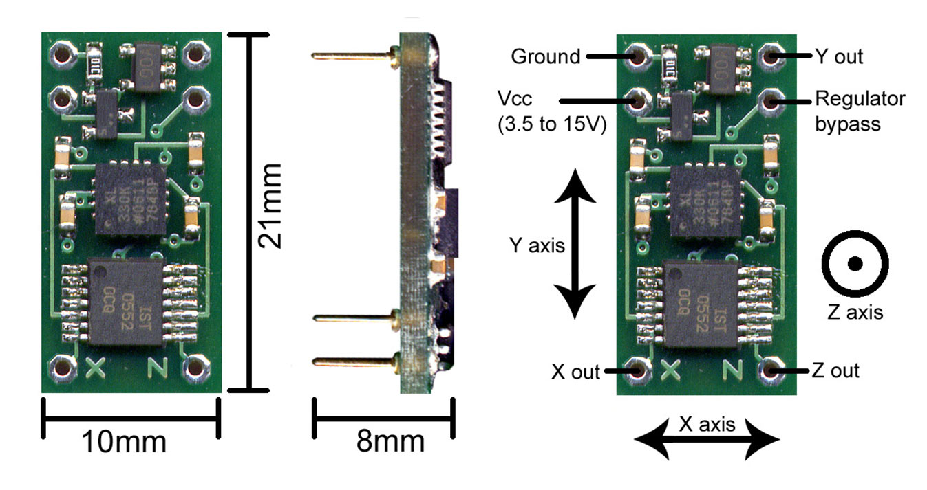

Measuring acceleration and tilt
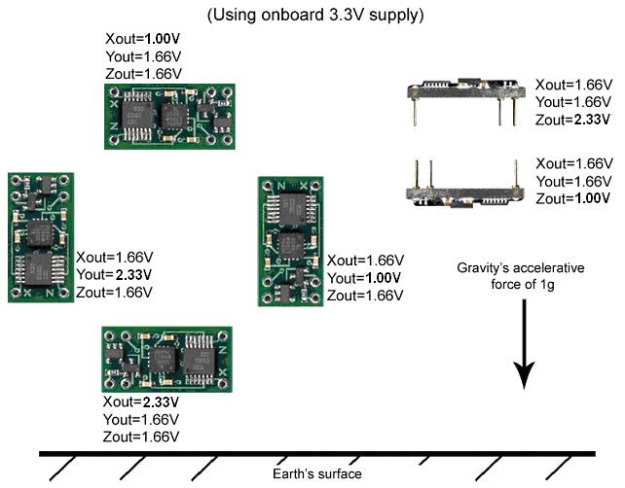
The voltage outputs on the DE-ACCM3D2 correspond to acceleration being experienced in the X, Y and Z directions. The output is ratiometric, so the output sensitivity (in mV/g) will depend on the supply voltage.

Sensitivity and accuracy
Here are some typical sensitivity values for common operating voltages:
Operating voltage | Sensitivity
3.6V | 720 mV/g
3.33V  (default when using onboard regulator) | 666 mV/g
3.0V | 600 mV/g
2.4V | 480 mV/g

Due to manufacturing variances when Analog Devices makes their accelerometer chips, these values aren’t always set in stone. Sensitivity can vary by up to 10% in extreme cases, and the 0g bias point can vary up to 5% on the X and Y axes, and 10% on the Z axis. For projects that require a very high degree of accuracy, we recommend that you incorporate measured calibrations into your hardware/software.

Example calculations

Voltage to acceleration example:
”With the 3.3V supply, the X output reads 2.46V. What acceleration does this correspond to?”
At 3.3V, the 0g point is approximately 1.66V
2.46V – 1.66V = +0.80V with respect to the 0g point
At 3.3V, if sensitivity is 666mV/g, 0.80 / 0.666 = 1.20g
Therefore the acceleration in the X direction is +1.20g
Acceleration to voltage example:
”I am powering the DE-ACCM3D with 2.4V. What voltage will correspond to an acceleration of -0.5g?”
At 2V, the 0g point is approximately 1.20V
If sensitivity at 2.4V is 480mV/g, -0.5 * 0.480 = -0.240V with respect to the 0g point.
1.20V – 0.240V = 0.96V
Therefore you can expect a voltage of approximately 0.96V when experiencing an acceleration of -0.5g.

Voltage to tilt example:
“With a Vcc of 3.0V, and the accelerometer oriented flat and parallel to ground in my robot, Yout is 1.50V. When my robot goes uphill, Yout increases to 1.84V. What is the slope of the hill?”
1.84V – 1.50 = +0.34V with respect to the 0g point.
With a sensitivity of 600mV/g, 0.34 / 0.600 = 0.567g
Sin⁻¹(0.567) = 34.5º
The slope of the hill is 34.5º in the Y axis

Tilt to voltage example:
“I am making an antitheft device that will sound an alarm if it is tilted more than 10º with respect to ground in any direction. I have measured the 0g bias point to be 1.701V, and I want to know what voltage to trigger the alarm at. I am using the onboard 3.3V source.”
Sin(10º) = 0.1736 so acceleration with a tilt of 10º will be 0.1736g
0.1736g * 0.666V/g = 0.116V with respect to the 0g point
1.701 + 0.116 = 1.817V
1.701 – 0.116 = 1.585V
Sound the alarm when the voltage reaches more than 1.817V or less than 1.585V.
Performance features
Output buffers
A bare accelerometer chip has an output impedance of 110kΩ, which is unsuitable for obtaining reliable measurements when connected to an analog to digital converter. On the DE-ACCM3D2, a quad rail to rail operational amplifier buffers the outputs from the LIS344ALH, greatly reducing output impedance. The absolute maximum load beyond which accuracy begins to seriously suffer is 3.3mA, or 500Ω.
Supply filtering
A 1uF ceramic bypass capacitor on the DE-ACCM3D2 provides excellent power supply decoupling. No external capacitors are necessary between Vcc and GND.
Output filtering and noise
A pair of 10nF capacitors limit the noise figure of the DE-ACCM3D2, without overly sacrificing bandwidth. RMS noise is typically 7.3mg, and output bandwidth is 500Hz - making it suitable for high frequency sampling of acceleration.

Regulator Bypass
Most people will want to power DE-ACCM3D2 using the onboard 3.3V regulator. However, if you are designing an application that needs a lower operating voltage, you can bypass the voltage regulator.
To do this, use the GND pin as normal. For the positive supply, solder a wire to the exposed pad labeled BYP. The onboard 1uF capacitor will still be in parallel with the accelerometer chip, so additional capacitance is not necessary unless running from a noisy source.

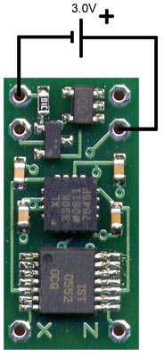
This would be useful for e.g. an application powered directly by 2 AA batteries or a lithium coin battery.
The minimum operating voltage when using bypass mode is 2.4V and the absolute maximum voltage that can be applied when bypassing the regulator is 3.6V.

Powering external devices
It is possible to use the DE-ACCM3D2’s voltage regulator to power external devices that require 3.3V, such as a low voltage microcontroller. These devices must be extremely low power so as to not overload the regulator! The maximum current that can be drawn in this way is 50mA, but ideally you should try keep things below 10mA. This diagram shows how to connect up an example microcontroller and all 3 axes.
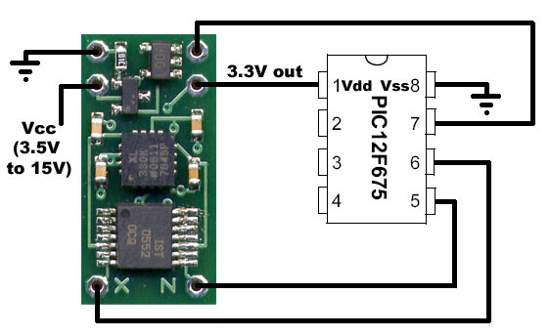

Additional capacitance across the microcontroller’s power pins may be necessary, depending on your particular setup.

Protection features
Reverse voltage
In the event that you mix up VCC and GND, a P channel MOSFET will prevent current from flowing – protecting the DE-ACCM3D2 from damage. This protection is only designed to work with DC voltages. Do not apply AC voltages to the power pins.
Output shorting
The operational amplifier driving the DE-ACCM3D2’s outputs is capable of handling a direct short from the X, Y and Z outputs to ground for as long as you want.

