
DE-ACCM6G Buffered ±6 Accelerometer
Features
Dual axis ±6g sense range
222mV/g sensitivity
500Hz bandwidth
Operating voltage 3 to 15V
Reverse voltage protection
Overvoltage protected
Output short protection
Standard DIP-14 form factor
Integrated power supply decoupling
Draws under 2mA
<2% typical 0g bias deviation from Vcc/2
Shiny gold pins to distract the enemy!

General Description
The DE-ACCM6G is an off the shelf 2 axis 6g accelerometer solution with analog outputs. It features integrated op amp buffers for direct connection to a microcontroller’s analog inputs, or for driving heavier loads.

Additional circuitry ensures that the product won’t be damaged by reversed power connections, or voltages above the recommended ratings.

The DE-ACCM6G is designed to fit the DIP-14 form factor, making it suitable for breadboarding, perfboarding, and insertion into standard chip sockets.

It is based on the ST MicroElectronics LIS244ALH for superior sensitivity and lower cost.

Applications
Motion, tilt and slope measurement
Shock sensing
Vehicle acceleration logging

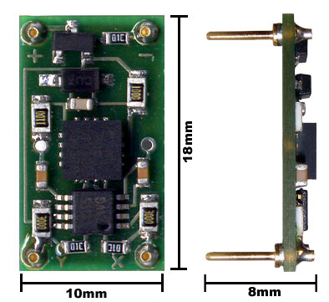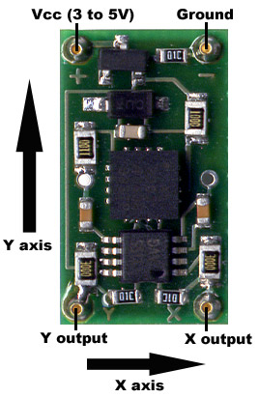

Measuring acceleration and tilt
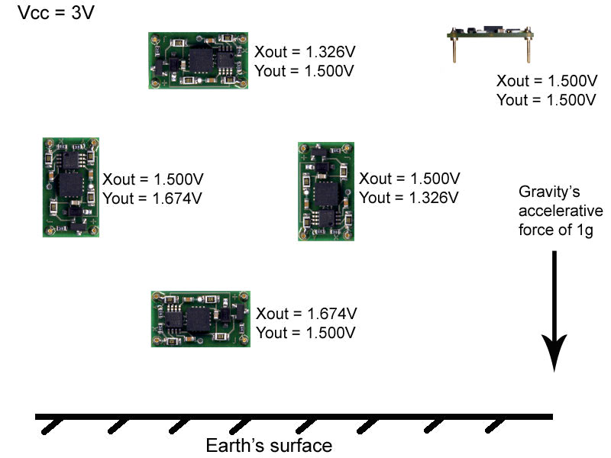
The voltage outputs on the DE-ACCM6G correspond to acceleration being experienced in the X and Y directions. The output is ratiometric, so the output sensitivity (in mV/g) will depend on the supply voltage. When supplied with 5V, sensitivity is typically 312mV/g. At 3V, sensitivity drops to 174mV/g. Zero acceleration (0g) will result in an output of Vcc/2 regardless of the voltage supplied to the unit.
Due to manufacturing variances when ST Microelectronics makes their accelerometer chips, these values aren’t always set in stone. They can vary by up to 4% in extreme cases, including the 0g bias point. For projects that require a very high degree of accuracy, we recommend that you incorporate measured calibrations into your hardware/software.
Voltage to acceleration example:
”The X output reads 3.06V. What acceleration does this correspond to?”
At 5V, the 0g point is approximately Vcc / 2 = 5.00 / 2 = 2.50V
3.06V - 2.50V = +0.56V with respect to the 0g point
At 5V, if sensitivity is 312mV/g, 0.56 / 0.312 = 1.79g
Therefore the acceleration in the X direction is +1.79g
Acceleration to voltage example:
”What voltage will correspond to an acceleration of -0.5g?”
At 3V, the 0g point is approximately 1.50V
If sensitivity at 3V is 174mV/g, -0.5 * 0.174 = -0.087V with respect to the 0g point.
1.50V – 0.087V = 1.413V
Therefore you can expect a voltage of approximately 1.413V when experiencing an acceleration of -0.5g.

Voltage to tilt example:
“With the accelerometer oriented flat and parallel to ground in my robot, Yout is 1.500V. When my robot goes uphill, Yout increases to 1.582V. What is the slope of the hill?”
1.582V – 1.500 = +0.082V with respect to the 0g point.
With a sensitivity of 174mV/g, 0.082 / 0.174 = 0.471g
Sin⁻¹(0.471) = 28.1º
The slope of the hill is 28.1º in the Y axis

Tilt to voltage example:
“I am making an antitheft device that will sound an alarm if it is tilted more than 10º with respect to ground in any direction. I have measured the 0g bias point to be 2.521V, and I want to know what voltage to trigger the alarm at.”
Sin(10º) = 0.1736 so acceleration with a tilt of 10º will be 0.1736g
0.1736g * 0.312V/g = 0.0542V with respect to the 0g point
2.521 + 0.0542 = 2.575V
2.521 – 0.0542 = 2.467V
Sound the alarm when the voltage reaches more than 2.575V or less than 2.467V.
Performance features
Output buffers
A bare accelerometer chip has an output impedance of 32kΩ, which is unsuitable for obtaining reliable measurements when connected to an analog to digital converter. On the DE-ACCM5G, a dual rail to rail operational amplifier buffers the outputs from the ADXL320, greatly reducing output impedance.
→ Buffer loading characteristics
For the purposes of this section, “max load” is defined as the resistive load that will cause a 2mV drop in the output voltage at 0g. If your application does not require this level of accuracy, the DE-ACCM5G can supply even more current at the cost of a larger drop in output voltage.

Max load is 0.83mA, or a resistance of 3kΩ

Supply filtering
A pair of resistors and a 0.1uF ceramic bypass capacitor on the DE-ACCM5G provide excellent power supply decoupling. No external capacitors are necessary between Vcc and GND.
Output filtering and noise
A pair of 10nF capacitors limit the noise figure of the DE-ACCM5G, without overly sacrificing bandwidth. RMS noise is typically 7.1mg, and output bandwidth is 500Hz - making it suitable for high frequency sampling of acceleration.
Protection features
Overvoltage
During prototyping, a common mistake is to power a device without checking the voltage output of one’s bench supply first. To ensure the LIS244ALH chip on a DE-ACCM5G won’t get damaged by this, a zener diode in parallel with the LIS244ALH’s power pins clamps the voltage supplied to a maximum of 5.6V. This is not intended to be a long-term voltage regulation solution. Do not run the DE-ACCM5G at more than its recommended input voltage of 3-5V for more than 5 minutes at a time!
It is important to note that the X and Y outputs remain unclamped, i.e. 0g still corresponds to Vcc/2 . So if one accidentally powers a DE-ACCM5G with 14V, the outputs would read 7v or more, which might be enough to damage an external device connected at the time.

Reverse voltage
Even the best engineers sometimes get their wires crossed. In the event that you mix up VCC and GND, a P channel MOSFET will prevent current from flowing – protecting the DE-ACCM5G from damage. This protection is only designed to work with DC voltages. Do not apply AC voltages to the power pins.

Improper insertion
A resistor network ensures that the DE-ACCM5G will not be permanently damaged if you insert it backwards (i.e. apply power to the output pins). The product will not function properly while it is used backwards. Do not leave the DE-ACCM5G inserted backwards for more than 5 minutes at a time.
Output shorting
The operational amplifier driving the DE-ACCM5G’s outputs is capable of handling a direct short from the X and Y outputs to ground for as long as you want.

