
DE-SW0XX Switching Voltage Regulator
Features
Drop-in replacement for LM78XX
Up to 30V input voltage
1.3V dropout voltage
3.3V and 5V output voltages available
1A continuous output current
Efficiency up to 87%
Integrated bypass capacitors
Integrated heat spreader
Weighs only 3.8g
Can drive inductive loads

General Description
The DE-SW0XX family of switch mode voltage regulators are designed to be the easiest possible way to add the benefits of switch-mode power to a new or existing project. The DE-SW0XX family is Pin-compatible with the common 78XX family of linear voltage regulators. They have integrated decoupling capacitors, so external capacitors are not generally necessary. Available voltages are 3.3 and 5 volts.

The DE-SW0XX family operates over a wide input voltage range, from (Vout+1.3V) to 30v, at up to one amp of continuous output current. Efficiencies are up to 87% (Figure 2) Ripple is less than 2% of output.

The DE-SW0XX family works on a breadboard, making it an ideal solution for prototyping and one-off circuits.

Applications
Battery powered applications
Robots
Servo power
Small DC motors
Lithium battery charging and maintenance
Point of load voltage regulation
Any application where a 78XX regulator is dissipating too much heat or a large heatsink is undesirable

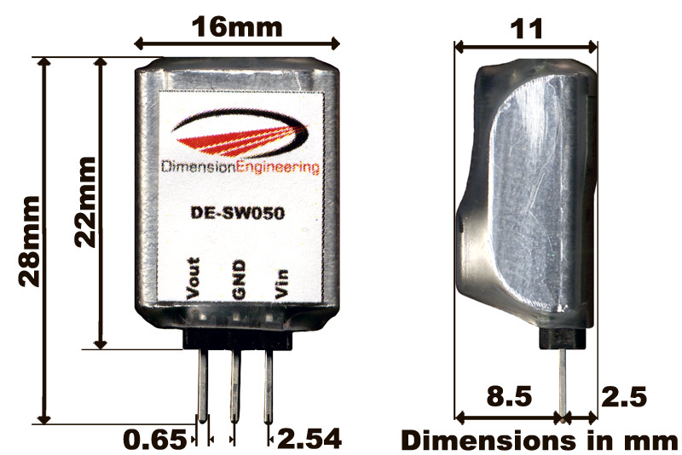

Typical Performance Characteristics
The device can be expected to perform as characterized within these parameters

Characteristic | Min | Typical | Max
Input voltage | Vout+1.3V |  | 30V
Output Current (RMS)¹ | 0A |  | 1A
Pulsed Output Current (5 sec) |  |  | 1.5A
Output Ripple | 30mV | 70mV | 100mV
Efficiency (See Figure 2 and Figure 3) | 65% | 83% | 87%
Transient response in load regulation (0-1A pulses, 1ms, Vp-p) |  | 4%
Power dissipation | 100mW | 800mW | 1.2W
Power output in still air | 0W |  | 5W
Quiescent current draw (Vin = 12V) |  | 16mA
Switching frequency | 230kHz | 270kHz | 290kHz
Thermal Derating in still air | See Figure 4
¹For input voltages above 25V, an output current of at least 40mA is needed to maintain the regulated output voltage. This can be accomplished by adding a 1kΩ load resistor, or by simply connecting the load you wanted to use anyway.

Absolute Maximum ratings
Operation beyond these parameters may permanently damage the device
Characteristic | Min | Max
Input voltage | 0V | 35v
Output Current | 0A | 1.5A
Power dissipation |  | 1.5W
Ambient Temperature | -20C | 70C

Overcurrent/overtemperature behavior
If the current limit has been considerably exceeded or if the device is overheated the product will gradually reduce the output voltage in an attempt to reduce the load on the device. Once the extra load is removed or the temperature is brought down, the desired output voltage will be restored. It is unlikely that you will destroy the regulator by exceeding the current/temperature ratings but we still recommend practicing good engineering techniques and do not overload the device beyond the recommended operating parameters.

Figure 2: Efficiency vs. Input Voltage
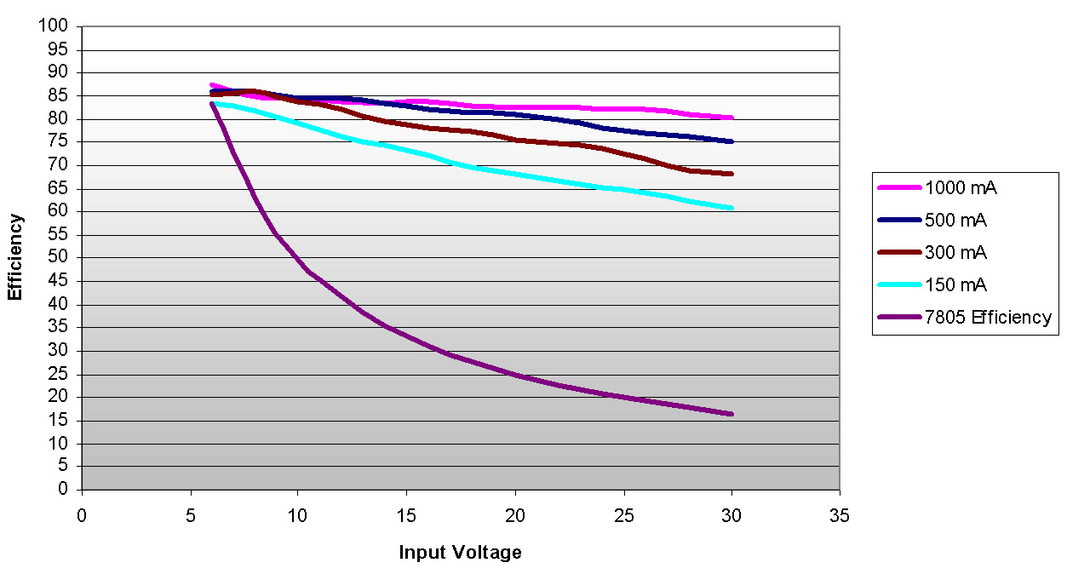

Figure 3: Efficiency vs. Output Current

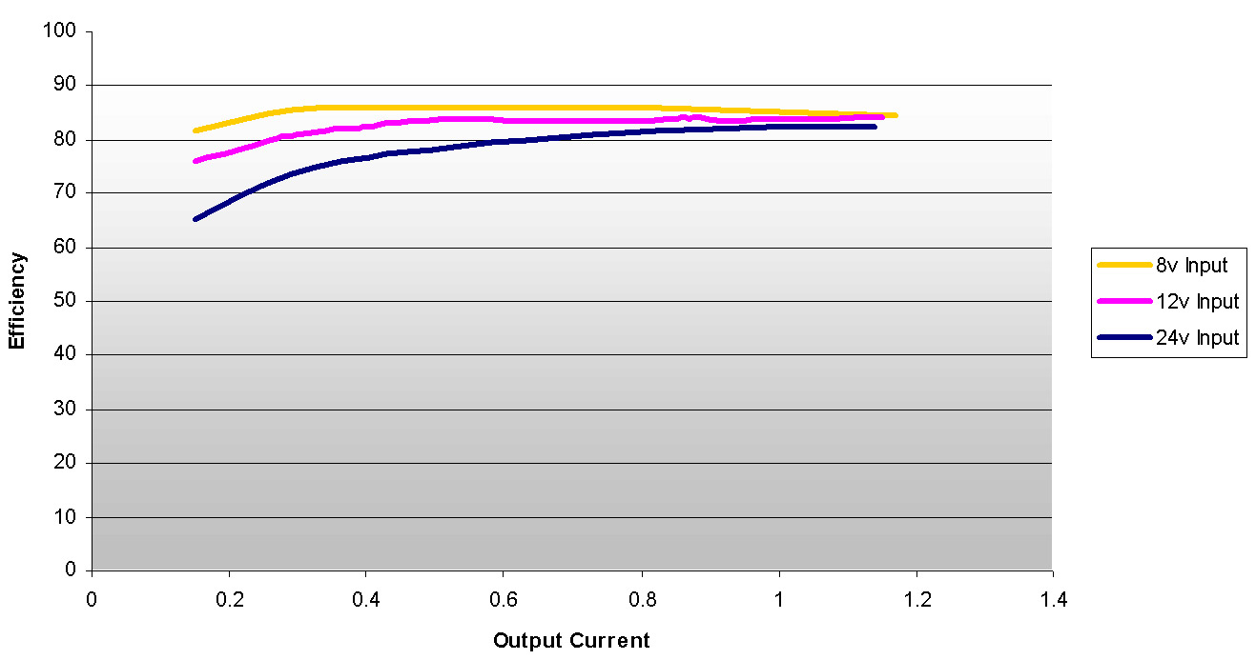

Figure 4: Thermal Derating in Still Air

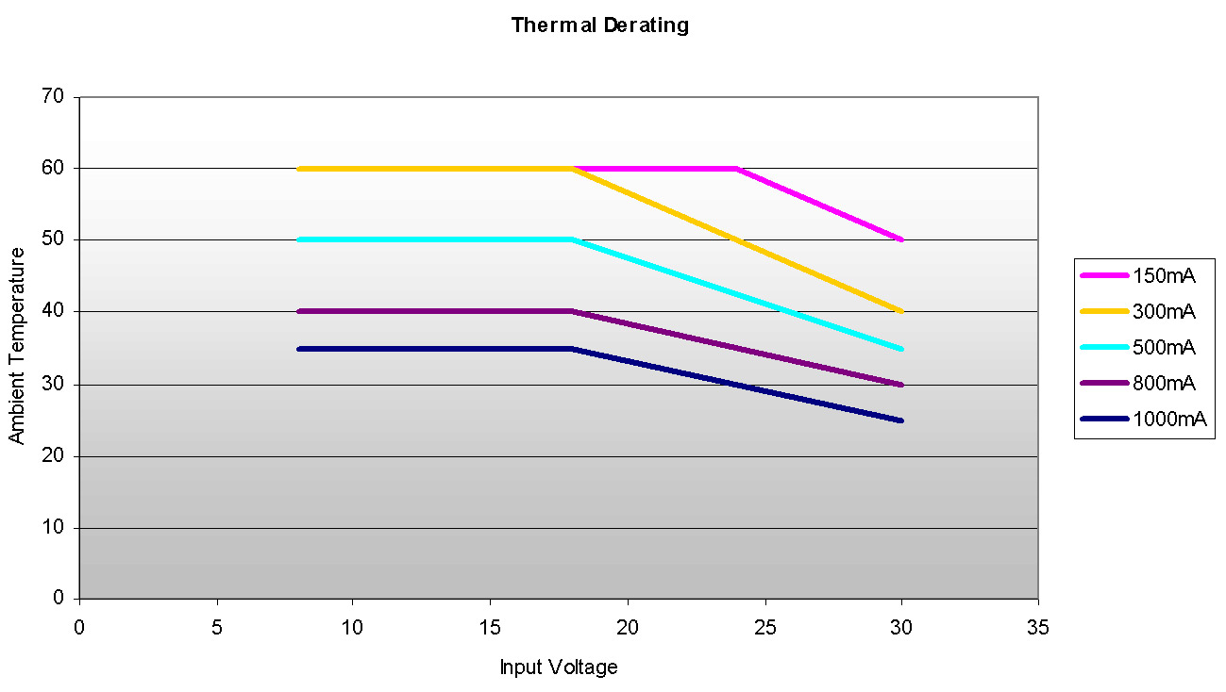

Typical Applications

General-purpose regulator
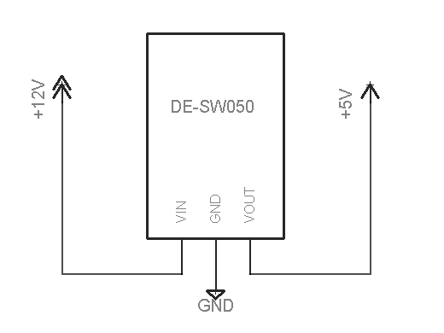

Regulator for ripple sensitive devices
