
DE-SWADJ Adjustable Switching Voltage Regulator
Features
Drop-in replacement for any of the LM78XX
regulators
Outputs any voltage between 1.25v and 13v
Adjustment is by a 25-turn potentiometer, making
it easy to dial in exactly the right output
3 to 30V input voltage
Up to 10W output power
1A continuous output current²
Efficiency up to 92%
Integrated bypass capacitors
Integrated heat sink
Weighs only 5.5g

General Description
The DE-SWADJ is designed to be the easiest possible way to utilize the benefits of switch-mode power when you need an unusual or easily changed voltage. The DE-SWADJ family is pin-compatible with the common 78XX family of linear voltage regulators, and can step down to 1.25v to 13v with no external circuitry required. It has integrated decoupling capacitors, so external capacitors are not generally necessary.

The DE-SWADJ operates over a wide input voltage range, from 3v to 30v, at up to one amp of continuous output current. Maximum power output is 10W. Efficiencies are up to 92% (Figure 2). Ripple is less than 2% of output.

The DE-SWADJ works on a breadboard, making it an ideal solution for prototyping and one-off circuits.

Applications
Battery powered applications
Robots
Battery charging and maintenance
Point of load voltage regulation
Any application needing a nonstandard voltage
Overclocking and over or under-volting standard products for more performance or less power draw

Figure 1
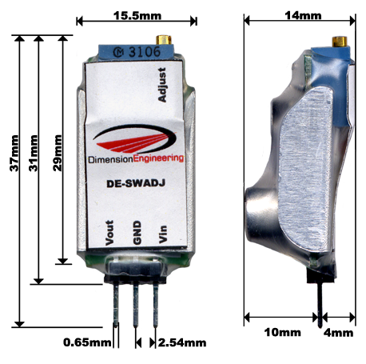
Typical Performance Characteristics
The device can be expected to perform as characterized within these parameters

Characteristic | Min | Typical | Max
Input voltage¹ | 3V |  | 30V
Output Voltage, Min |  | 1.25v
Output Voltage, Max | 13v | 14v | 14.5v
Output Power |  |  | 10W
Output Current (RMS)² | 0A |  | 1A
Pulsed Output Current (5 sec) |  |  | 1.5A
Output Ripple | 30mV | 70mV | 100mV
Efficiency (See Figure 2) | 55% |  | 92%
Transient response in load regulation (0-1A pulses, 1ms, Vp-p) |  | 4%
Power dissipation | 100mW | 800mW | 1.2W
Power output in still air | 0W |  | 10W
Switching frequency | 230kHz | 270kHz | 290kHz
¹ The sum of input and output voltages must not exceed 40v
² Limited at high voltages by the max power output – see graph below
² For input voltages above 25V, an output current of at least 40mA is needed to maintain the regulated output voltage. This can be accomplished by adding a 1kΩ load resistor, or by simply connecting the load you wanted to use anyway.

Absolute Maximum ratings
Operation beyond these parameters may permanently damage the device
Characteristic | Min | Max
Input voltage | 0V | 35v
Output Current | 0A | 1.5A
Power dissipation |  | 1.5W
Ambient Temperature | -20C | 70C

Overcurrent/overtemperature behavior
If the current limit has been considerably exceeded or if the device is overheated the product will gradually reduce the output voltage in an attempt to reduce the load on the device. Once the extra load is removed or the temperature is brought down, the desired output voltage will be restored. It is unlikely that you will destroy the regulator by exceeding the current/temperature ratings but we still recommend practicing good engineering techniques and do not overload the device beyond the recommended operating parameters.

Additional notes
DE-SWADJ uses a 25 turn worm gear driven potentiometer and cannot wiggle loose. Do not apply glue to the voltage adjustment pot. Turning the pot clockwise reduces the output voltage.

For best performance, mount DE-SWADJ in an open space with some air flowing across it to keep it cool.

Figure 2: Efficiency vs. Input Voltage

