
DE-SWADJ 3A Adjustable Voltage Regulator
Features
Drop-in replacement for any of the LM78XX
regulators
Outputs any voltage between 3v and 13v
Adjustment is by a 25-turn potentiometer, making
it easy to dial in exactly the right output
5 to 35V input voltage
Up to 25W output power
3A continuous output current²
Efficiency up to 96%
Integrated bypass capacitors
Integrated heat sink
Weighs only 10g

General Description
The DE-SWADJ 3 is designed to be the easiest possible way to utilize the benefits of switch-mode power when you need an unusual or easily changed voltage. The DE-SWADJ family is pin-compatible with the common 78XX family of linear voltage regulators, and can step down to 3v to 13v with no external circuitry required. It has integrated decoupling capacitors, so external capacitors are not generally necessary.

The DE-SWADJ 3 operates over a wide input voltage range, from 5v to 35v, at up to three amps of continuous output current. Maximum power output is 25W. Efficiencies are up to 96% (Figure 2). Ripple is less than 1% of output.

The DE-SWADJ 3 works on a breadboard, making it an ideal solution for prototyping and one-off circuits.

Applications
Battery powered applications
Robots
Battery charging and maintenance
Point of load voltage regulation
Any application needing a nonstandard voltage
Overclocking and over or under-volting standard products for more performance or less power draw

Figure 1
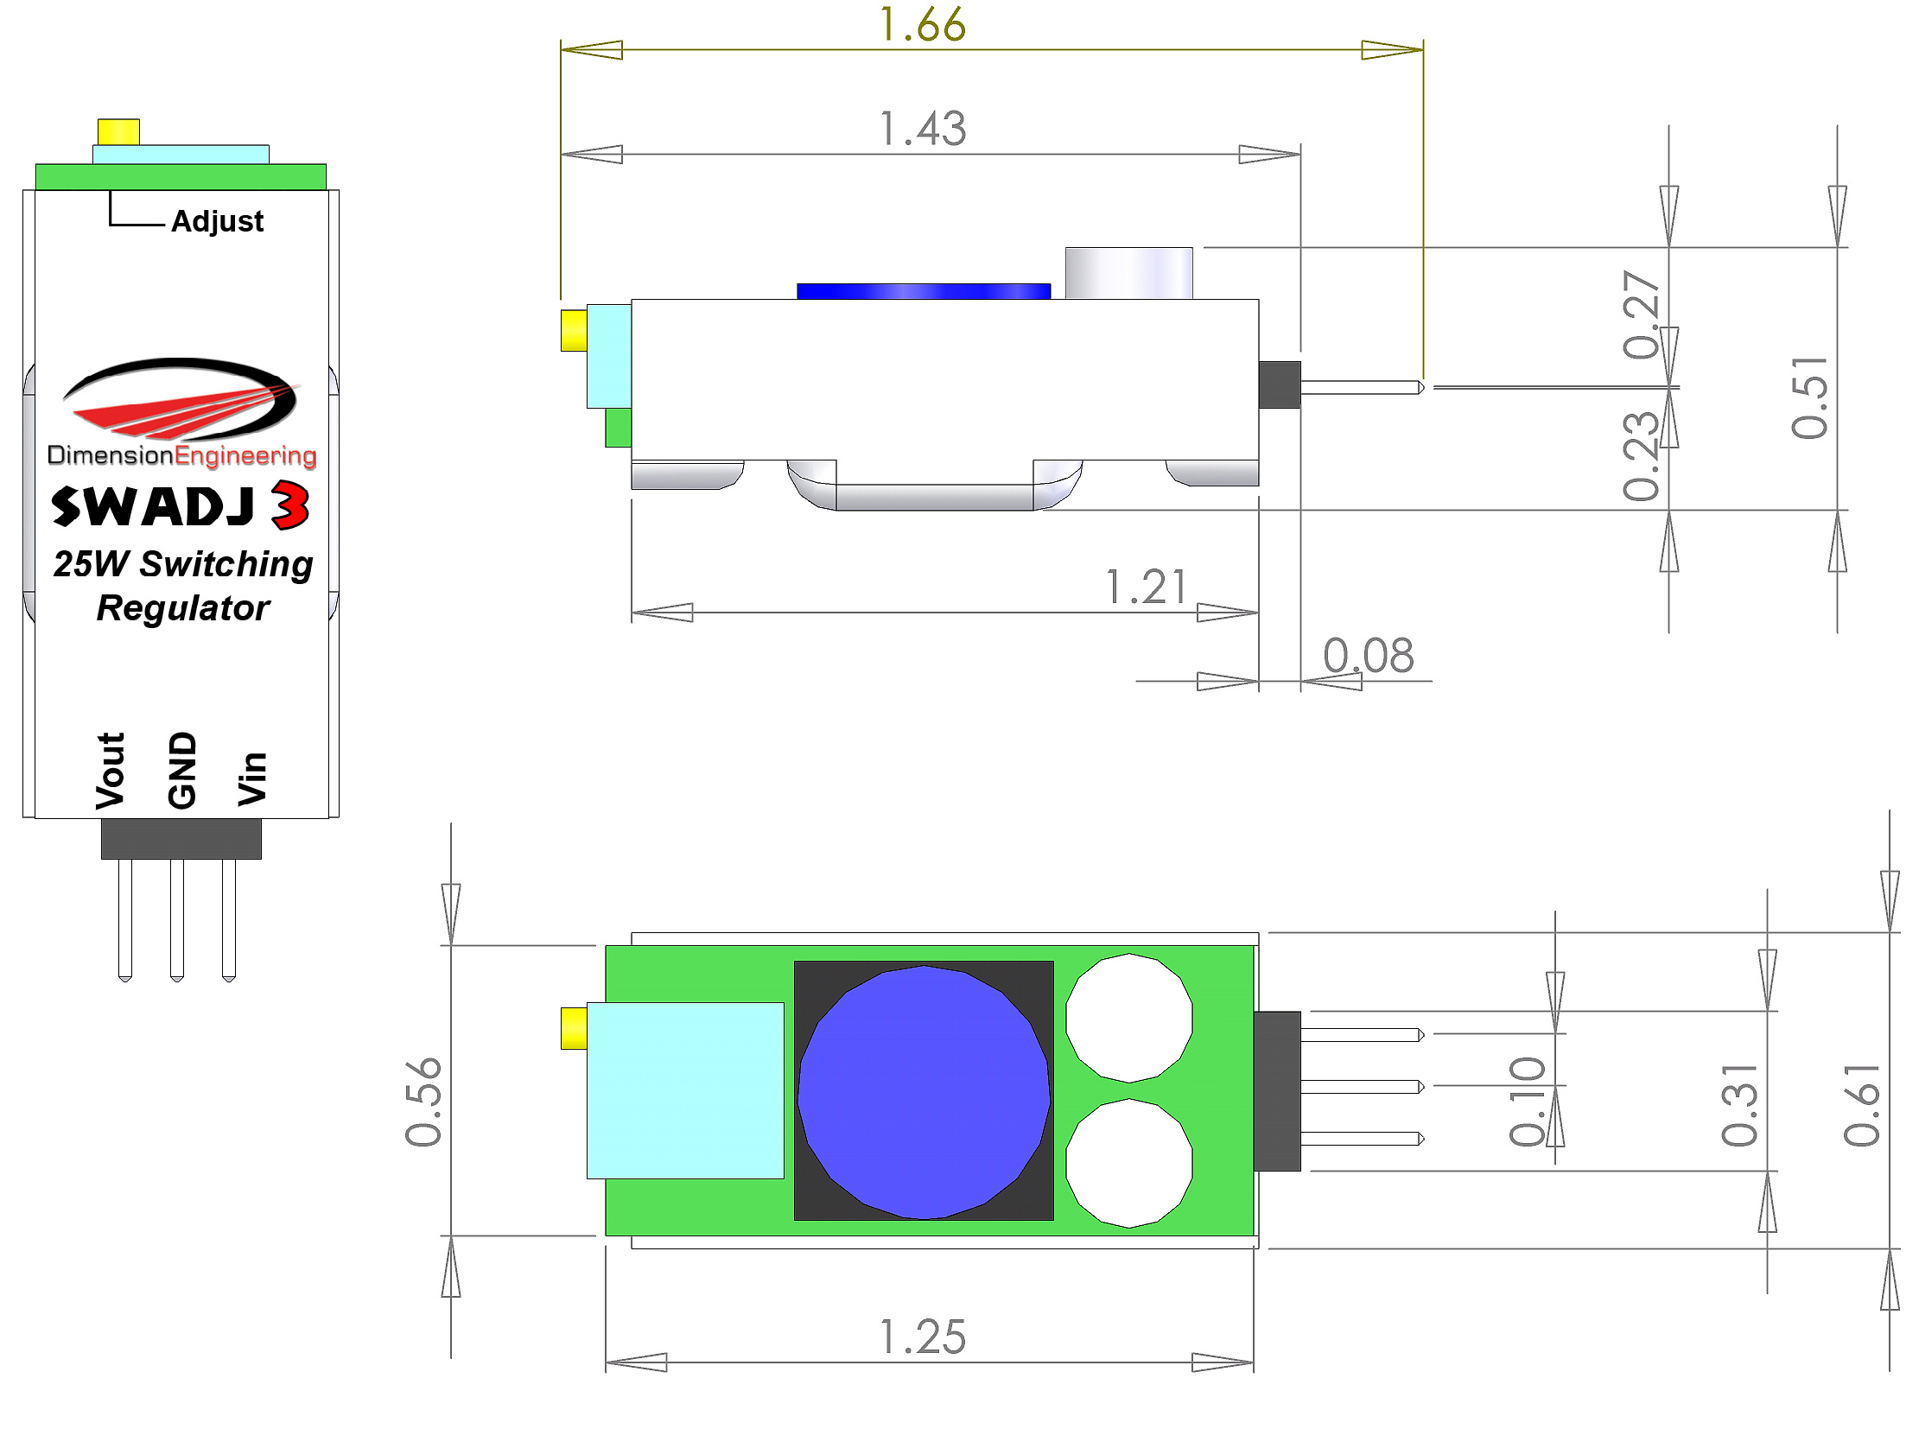
(Measurements are in inches.)

Typical Performance Characteristics
The device can be expected to perform as characterized within these parameters

Characteristic | Min | Typical | Max
Input voltage | 5V |  | 33.6V
Output Voltage, Min |  | 3v
Output Voltage, Max | 12v | 12.5v | 13v
Output Power |  |  | 25W
Output Current¹ | 0A |  | 3A
Output Ripple | 10mV | 25mV | 40mV
Efficiency (See Figure 2) | 66% | 90% | 96%
Power dissipation | 120mW | 1.12W² | 2W
Switching frequency |  | 500kHz
¹ Limited at high voltages by the max power output – see graph below
² Rating at 16Vin to 6 Vout, with a load of 2A.

Absolute Maximum ratings
Operation beyond these parameters may permanently damage the device
Characteristic | Min | Max
Input voltage | 4.9V | 36v
Output Current | 0A | 3A
Power dissipation |  | 3.4W
Ambient Temperature | -20C | 70C

Use

Connect your DE-SWADJ 3 to a power supply or battery and a voltmeter. Turn the worm gear attached to the potentiometer (labeled Adjust) clockwise to reduce output voltage and counterclockwise to increase it. Be sure to adjust to the desired output voltage before attaching the DE-SWADJ 3 to your application!

Overcurrent/overtemperature behavior
If the current limit has been considerably exceeded or if the device is overheated the product will gradually reduce the output voltage in an attempt to reduce the load on the device. Once the extra load is removed or the temperature is brought down, the desired output voltage will be restored. It is unlikely that you will destroy the regulator by exceeding the current/temperature ratings but we still recommend practicing good engineering techniques and do not overload the device beyond the recommended operating parameters.

Additional notes
DE-SWADJ 3 uses a 25 turn worm gear driven potentiometer and cannot wiggle loose. Do not apply glue to the voltage adjustment pot.

For best performance, mount DE-SWADJ 3 in an open space with some air flowing across it to keep it cool.

Figure 2: Efficiency vs. Input Voltage

