

LipoShield installation guide
November 2005

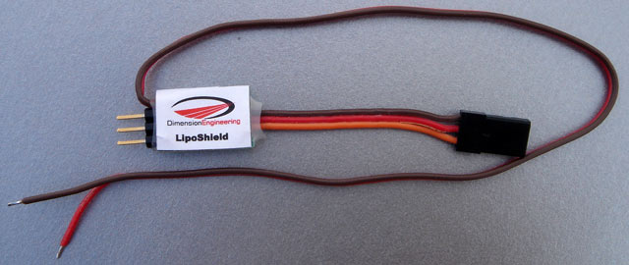

Introduction:

LipoShield is a low voltage cutoff device which enables any ESC to be used with lithium battery packs. It installs easily between your receiver and ESC and provides a reliable 3.0V per cell soft cutoff to prevent over-discharge damage to your expensive lipo packs. This installation guide will walk you through the usual way to install a LipoShield.
Required Materials:

ESC
LipoShield
Battery connector (usually already installed on the ESC)
2 short pieces of heat shrink tubing
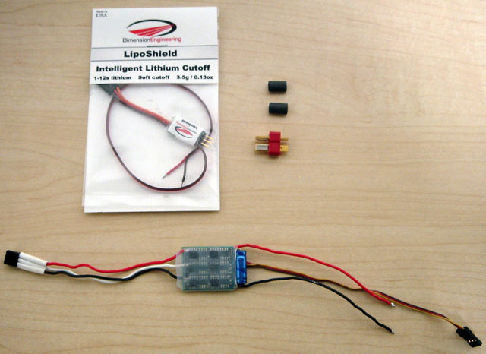

Installation Instructions:

Step 1:
You must connect the long brown and red cable coming from the LipoShield to the ESC side of your battery connector. Begin by removing the connector from your ESC if attached, then thread the ESC and LipoShield battery wires through two pieces of heat shrink tubing, as shown below.
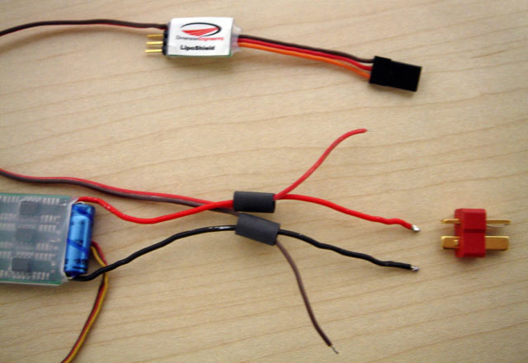

Step 2:
Solder the LipoShield and ESC wires to the connector, as shown below.
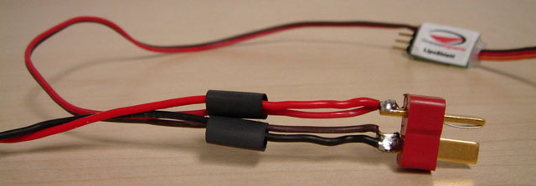

Step 3:
Shrink the heat shrink tubing around the exposed solder joint on the connector, as shown below.
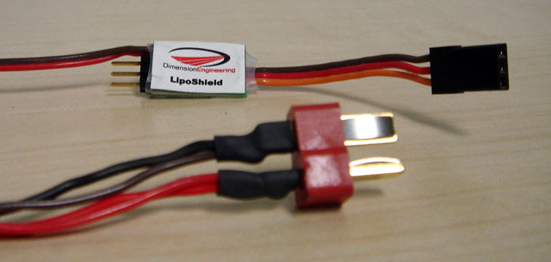

Step 4:
Turn the LipoShield over and you will see the polarity marking for the ESC. Depending on your brand of ESC, the signal wire that connects to the pin marked with the yellow-circled ‘S’ may be yellow, white or orange. Plug the ESC’s throttle cable into the LipoShield as shown below.

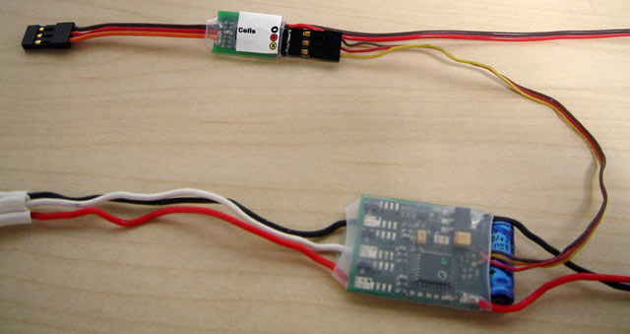

Step 5:
Plug the radio connector of the LipoShield into the throttle port of your receiver.
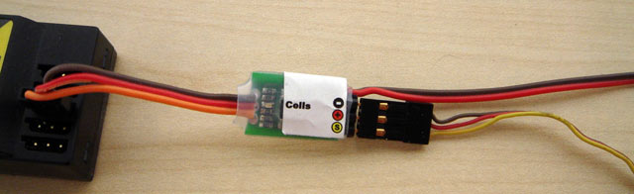

Step 6:
Secure the LipoShield to the airframe with Velcro, double sided tape or rubber bands. Verify ESC and servo functionality before your first flight. This completes the installation of the LipoShield. After you plug in the battery, check that the green light marked “Cells” is blinking the correct number of times. A 3s battery pack should cause the light to blink three times, pause, blink three more times, and so on. If the LipoShield does not blink the correct number of cells, then the battery is in a state of deep discharge and must be charged before flight.

