
Negatron
Features
-1.3V to -12V output voltage range
4V to 14V input voltage range
Up to 250mA out at -12V when powered from 12V
<100mV typical ripple
No external components normally needed
Weighs 5 grams
Thermal, overcurrent and short circuit protection

General Description
Negatron takes a positive input voltage and generates an adjustable negative voltage. It is a highly integrated adjustable buck-boost converter.

The output voltage is set with the small screw potentiometer on top. Negatron is capable of outputting voltages greater or lesser in magnitude than the input voltage, for example with a 7.4V input you could generate -5V out or -12V out.

The Negatron has a similar pin-out to the common 78XX series of linear voltage regulators, so it will work with breadboards and other popular prototyping methods.
Negatron works most efficiently from a 12V supply.

Applications
Lab work and prototyping
Op-amp negative supply rail
Powering small audio amplifiers
Powering sensors
Solar powered applications
Battery charging
Renewable energy source applications

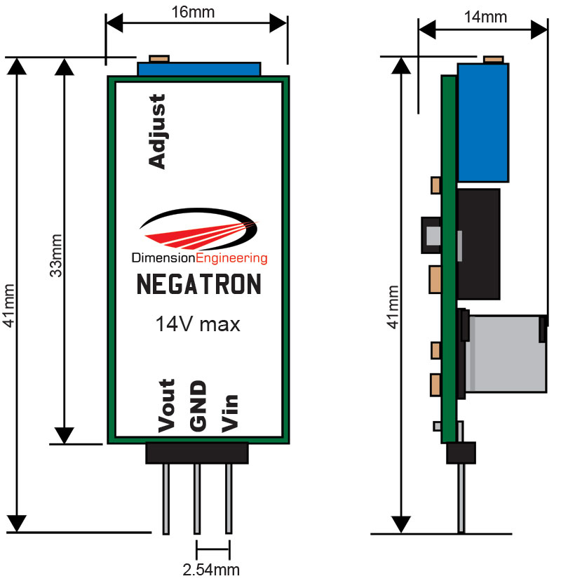

Characteristic | Min | Typical | Max
Input Voltage | 4V | 5V to 12V | 14V
Output Voltage | -1.275V | -1.3V to -12V | -15V¹
Continuous Output Current |  |  | 0.5A²
Output Ripple (Vp-p) | 20mV | 80mV | 150mV
Quiescent current draw | 16mA | 40mA | 116mA³
Efficiency |  | 77% | 79%
Recommended ambient temperature range | -20ºC | 25ºC | 55ºC⁴
Switching frequency | 230kHz | 270kHz | 290kHz

¹Max output varies with manufacturing processes.
² The 0.5A rating is when running from 12V in and converting to -5V out. Please see the tables later on in the datasheet for more details on Negatron’s current handling capabilities at different voltages.
³ Worst case of 4V in, -12V out
⁴Ambient temperatures higher than room temperature will decrease the amount of current Negatron can handle. For optimal performance, mount Negatron in an open space with air flowing across it.

Adjusting the output voltage
With the adjustment screw facing you, turning it clockwise makes the voltage increasingly negative.

Current limits and efficiency
Negatron operates across an especially wide input and output voltage range so its current handling capability will vary from situation to situation. Here is a table of typical max loads you can power with a Negatron, depending on your input voltage.

5V in
Output Voltage (V) | -5 | -9 | -12
Max current out (mA) | 180 | 125 | 110
Efficiency (%) | 69 | 67 | 64
9V in
Output Voltage (V) | -5 | -9 | -12
Max current out (mA) | 500 | 290 | 150
Efficiency (%) | 75 | 77 | 72
12V in
Output Voltage (V) | -5 | -9 | -12
Max current out (mA) | 500 | 350 | 250
Efficiency (%) | 77 | 79 | 76

As you can see, Negatron is able to operate from lower voltages but running it off of 12V allows you to draw more current on the output.

Overcurrent behavior
If the current limit has been slightly exceeded, the output ripple will substantially increase and oscillation may occur. Adding extra output capacitance (1000uF) can sometimes help in applications where you are just over the limit of what Negatron can handle. When the current limit is substantially exceeded, Negatron will gradually bring the output voltage closer to zero to try to protect itself. As with any electronic component, keep within the recommended operating parameters to ensure long product life.

Over-temperature behavior
If Negatron is overheated to beyond 100ºC it will gradually reduce the output voltage in an attempt to reduce the load on the device. Once the extra load is removed or the temperature is brought down, the desired output voltage will be restored. It is unlikely that you will destroy a Negatron’s circuitry by exceeding the current/temperature ratings but we still recommend practicing good engineering techniques and do not overload the device beyond the recommended operating parameters. If you allow Negatron to overheat, the heat-shrink may melt and tear.

Additional notes
Negatron uses an 11 turn worm gear driven potentiometer and cannot wiggle loose. Do not apply glue to the voltage adjustment pot.

Negatron should be mounted at least 2 inches away from any circuitry that is sensitive to RF.
For best performance, mount Negatron in an open space with some air flowing across it to keep it cool.
Usage example
