

ParkBEC installation guide
June 2007

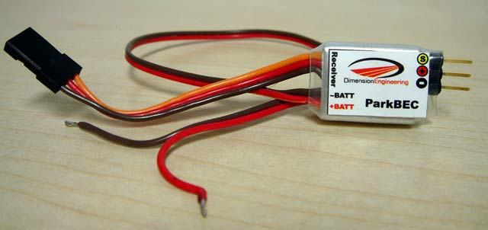

Introduction:

The ParkBEC is a switch-mode BEC specifically designed for parkflyer type aircraft. It weighs only 6.2 grams with full wires, and as little as 4.1g if the wires are removed. It is designed for use with flight batteries from two to eight lithium cells, or up to 20 Nickel cells. It is able to supply 1.25A continuously and 60 second peaks of up to 1.5A. It incorporates a throttle pass-through feature, which allows you to simply plug it in and go, without having to modify your ESC. The ParkBEC is designed for use with ESCs that are already lithium-aware and have the proper cutoff voltage. If your ESC is not lithium capable and you are running lithium cells, please use the Dimension Engineering SmartBEC instead, or use an external battery-monitoring device like CellShield.

Installation Instructions:

Step 1:
Connect the brown and red wires labeled +BATT and –BATT to the positive and negative input wires of your ESC. It is usually most convenient to attach the wires at the connector as shown.
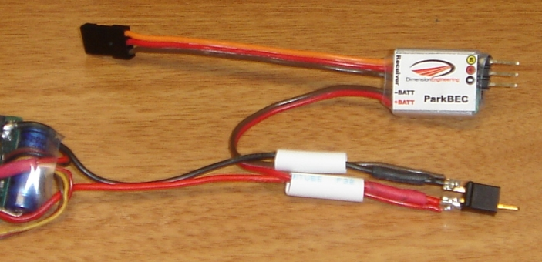

Step 2:
Plug the radio connector of your ESC into the port on the ParkBEC in the proper polarity. Depending on your brand of ESC, the signal wire that connects to the pin marked with the yellow-circled ‘S’ may be yellow, white or orange. By plugging the ESC into the ParkBEC, the BEC function of the ESC is bypassed and no further modification of the ESC is necessary. This will not affect the ESC’s low voltage cutoff or any other ESC function.
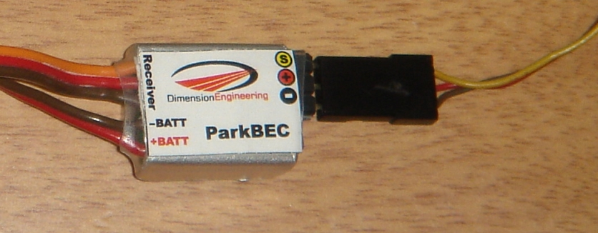

Step 3:
Plug the radio connector of the ParkBEC into the throttle port of your receiver.
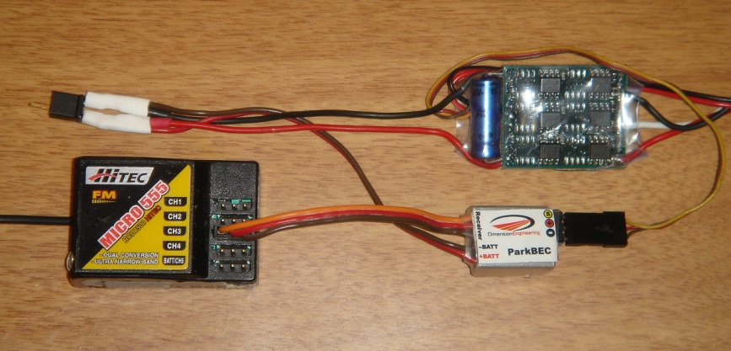

Step 4:
Secure the ParkBEC to the airframe with Velcro, double sided tape or rubber bands. Verify ESC and servo functionality before your first flight. For best results, ensure that the ParkBEC is installed at least 2 inches away from your receiver. This completes the installation of the ParkBEC.

Recommended setups:

The ParkBEC is designed to supply up to 1.25 amps continuously and 1.5A for 60 seconds peak to the servos. The amount of current drawn by the servos varies considerably between airplanes and flying styles. A 100mph EDF will likely draw much more current than a floater. For high performance setups, please use a Dimension Engineering ServoSense to measure the in-flight average and peak current draw of your system. The following are provided as preliminary guidelines.

Servo Type | Max number of servos
6g servos (HS-50, GWS Pico,etc.) | 6
9g servos (HS-55, GWS naro, etc.) | 6
“micro” servos (HS-81, GWS park) | 4
“Standard” servos | 4

