

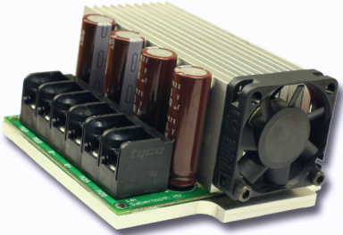

Sabertooth 2x50HV
Quick Start Guide
Specifications

Input voltage: 12-48V nominal, 62V absolute max.

Output Current: Up to 50A continuous per channel. Peak loads may be up to 100A per channel for a few seconds.
Recommended power sources are:
- 10 to 40 cells high capacity NiMH or NiCd
- 3s to 12s lithium ion or lithium polymer. Sabertooth motor drivers have a lithium battery mode to prevent cell damage due to over-discharge of lithium battery packs.
- 12v to 48v high capacity lead acid
- 12v to 48v power supply (with a custom-set maximum voltage).

All batteries must be capable of maintaining a steady voltage when supplying 40+ amps

Full manual and documentation can be found at
http://www.dimensionengineering.com/datasheets/Sabertooth2x50HV.pdf

Dimensions:
Size: 4.17” x 3.5” x 1.85” 106 x 90 x 47mm
Weight: 11oz / 292g
Hooking up the Sabertooth Motor Driver
All connections to the Sabertooth are done with screw terminals. This makes it easy to set up and reconfigure your project. If you’ve never used screw terminal connections before, here is an overview.
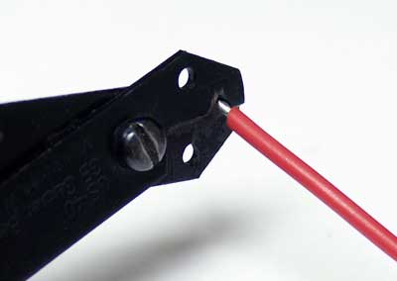 | 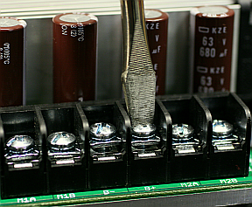
Step 1: Strip the wire which you are using approximately ¼” The wires may be 10 gauge to 24 gauge. Use thicker wire for high current applications. | Step 2: With a large screwdriver, turn the top screw counter-clockwise until it stops gently.
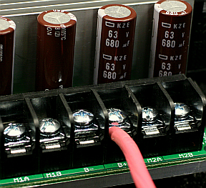 | 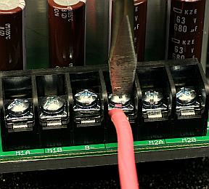
Step 3: Insert the stripped portion of the wire into the opening in the screw terminal. Larger wires can use both sides of the terminal or have multiple wires in parallel. | Step 4: Turn the top screw clockwise until you encounter resistance, then tighten the screw firmly. Pull on the wire gently to ensure that it is secured.
Battery Terminals: B+ and B-
The battery or power supply is connected to terminals B- and B+. B- connects to the negative side of the battery (usually black.) B+ connects to the positive side of the battery (usually red or yellow.) It is best to connect the battery through a connector instead of directly to the driver. This makes it easy to unplug the battery for charging, and prevents plugging in the battery backwards.

Motor Terminals: M1A M1B M2A and M2B
Motor 1 is connected to terminals M1A and M1B as shown on the back outside cover. If the motor runs in the opposite way that you want, you may reverse the motor wires to reverse rotation. Motor 2 is connected to terminals M2A and M2B.

Signal Input Terminals: S1 and S2
The input signals that control the Sabertooth are connected to terminals S1 and S2. If you are running in analog mode, it is recommended to have both signal inputs connected before applying power to the device. Otherwise, the motors may start unexpectedly.

Power terminals: 0V and 5V
The 0V and 5V connections are used to power and interface to low-power control circuits.

The 5V connection is a 5v power output. This takes power from the Sabertooth 2x50’s internal switching BEC and is useful for supplying low-current devices, such as a potentiometer or a radio receiver.

The 0V connection is the signal ground for the Sabertooth. In order to receive input signals correctly, it must be connected to the ground of the device sending the signals.

Please see the back outside cover for a hookup diagram.
Indicator LEDs
Sabertooth 2x50 has three indicator LEDs.
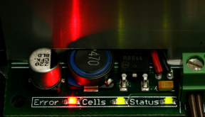
All LEDs on

The green LED marked Status is used to communicate various information about the current state. In most cases Status acts as a power indicator. In R/C mode, it glows dimly if there is no RC link present and brightly if there is an RC link.

The green LED marked Cells is only used in lithium mode. It blinks to indicate the number of lithium cells detected.

The red Error LED illuminates if the Sabertooth has detected a problem. It will light if the driver has shut down due to a depleted battery or due to overheating, overcurrent or overvoltage. If commanding acceleration causes the motor to jerk and the Error LED to flash on and off, the battery is depleted.

Mounting the Sabertooth 2x50
The Sabertooth is supplied with four mounting holes. The centers of the mounting holes form a 3” by 3.25” rectangle. The holes are .125 inches in diameter. The proper size screw is a 4-40 round head machine screw. Four 5/8” long machine screws and nuts are included.
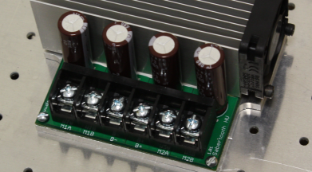
Mounted directly to a metal frame

Mode 1: Analog Input
Analog input mode takes one or two analog inputs and uses those to set the speed and direction of the motor. The valid input range is 0v to 5v. This makes the Sabertooth easy control using a potentiometer, the PWM output of a microcontroller (with an RC filter) or an analog circuit.

Mode 2: R/C Input
R/C input mode takes two standard R/C channels and uses those to set the speed and direction of the motor. There is an optional timeout setting. When timeout is enabled, the motor driver will shut down on loss of signal. This is for safety and to prevent the robot from running away should it encounter interference and should be used if a radio is being used to control the driver. If timeout is disabled, the motor driver will continue to drive at the commanded speed until another command is given.

Mode 3: Simplified serial.
Simplified serial mode uses TTL level RS-232 serial data to set the speed and direction of the motor. This is used to interface the Sabertooth to a PC or microcontroller. If using a PC, a level converter such as a MAX232 chip must be used. The baud rate is set via DIP switches. Commands are single-byte. There is also a Slave Select mode which allows the use of multiple Sabertooth 2x25 from a single microcontroller serial port.

Mode 4: Packetized serial
Packetized serial mode uses TTL level RS-232 serial data to set the speed and direction of the motor. There is a short packet format consisting of an address byte, a command byte, a data byte and a 7 bit checksum. Address bytes are set via dip switches. Up to 8 Sabertooth motor drivers may be bussed together on a single serial line.
DIP Switch Guide

Analog input mode is selected by setting switches 1 and 2 to the UP position. Inputs S1 and S2 are configured as analog inputs. The output impedance of the signals fed into the inputs should be less than 10k ohms for best results. If you are using a potentiometer to generate the input signals, a 1k, 5k or 10k linear taper pot is recommended. In all cases, an analog voltage of 2.5V corresponds to no movement. Signals above 2.5V will command a forward motion and signals below 2.5V will command a backwards motion.
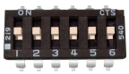
Analog Input Mode

R/C Input mode is used with a standard hobby Radio control transmitter and receiver. R/C mode is selected by setting switch 1 to the DOWN position and switch 2 to the UP position. It is necessary to obtain one or more servo pigtails and attach them to the Sabertooth. R/C Input mode takes a 1000us to 2000us servo signal; 1000us is full reverse throttle, 1500us is a stop command, and 2000us is full forward.
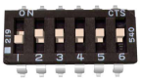
R/C Input Mode

Microcontroller Mode takes a signal similar to R/C Input mode, but autocalibration and timeout features are disabled. A 1000us servo signal is full reverse, a 1500us signal is a stop command and a 2000us signal is full forward. It is selected by setting switches 1 and 6 to the DOWN position and switch 2 to the UP position.
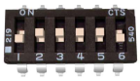
Microcontroller Mode
Mixing/Independent Mode applies to R/C, Microcontroller and Analog input modes. It is controlled by DIP switch 4. With DIP Switch 4 in the ON position, Mixing is engaged to provide differential drive control. Signals going to the S1 terminal will control throttle of both motors, and signals going to the S2 terminal will control steering of both motors. With Switch 4 in the OFF position, Independent mode is engaged. Signals to S1 will control the motor connected to M1A and M1B, and signals to S2 will control motor connected to M2A and M2B.
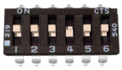
Switch 4: Mix/Ind Mode

Linear/Exponential Mode applies to R/C, Microcontroller and Analog input modes. It is controlled by DIP switch 5. With switch 5 in the ON position, Linear mode is engaged and the motor outputs are exactly proportional to signal inputs. With switch 5 in the OFF position, sensitivity near the center point is softened to increase control at lower throttles.
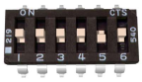
Switch 5: Lin/Expo Mode

Lithium Mode applies to all control input modes and engages the Sabertooth’s built-in lithium cutoff. The Cells LED will flash the number of lithium cells detected as determined by input voltage when lithium mode is engaged. When input voltage reaches 3.0V per cell, the soft lithium cutoff will engage.
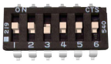
Switch 3: Lithium Mode
Simplified Serial uses TTL level single-byte serial commands to set the motor speed and direction. Sending a character between 1 and 127 will control motor 1. 1 is full reverse, 64 is stop and 127 is full forward. Sending a character between 128 and 255 will control motor 2. 128 is full reverse, 192 is stop and 255 is full forward. Sending a command of 0 will shut down both motors.
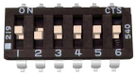
Simplified Serial Mode
This mode selected by setting switch 1 to the UP position and switch 2 to the DOWN position. In this mode setting switches 4 and 5 to the UP position designates 2400 baud; for other baud rates and instructions on chaining multiple Sabertooth units together in this mode please see the manual.
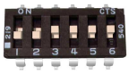
Packetized Serial Mode
Packetized Serial uses TTL level multi-byte serial commands to set the motor speed and direction. The transmit line from the host is connected to S1. It is selected by setting switches 1 and 2 to the DOWN position. Please see the manual for further instructions on using Packetized Serial mode.

