
Sabertooth 2X5 Quick Start Guide
December 2006

Congratulations on your purchase of a Sabertooth 2X5 regenerative motor driver. Sabertooth 2X5 is one of the most flexible and configurable motor drivers on the market. As a result, it must be set to the correct operating mode before use. Below is a generalized hookup diagram of a Sabertooth 2X5. On the reverse side is a chart of some of the most commonly used operating modes.
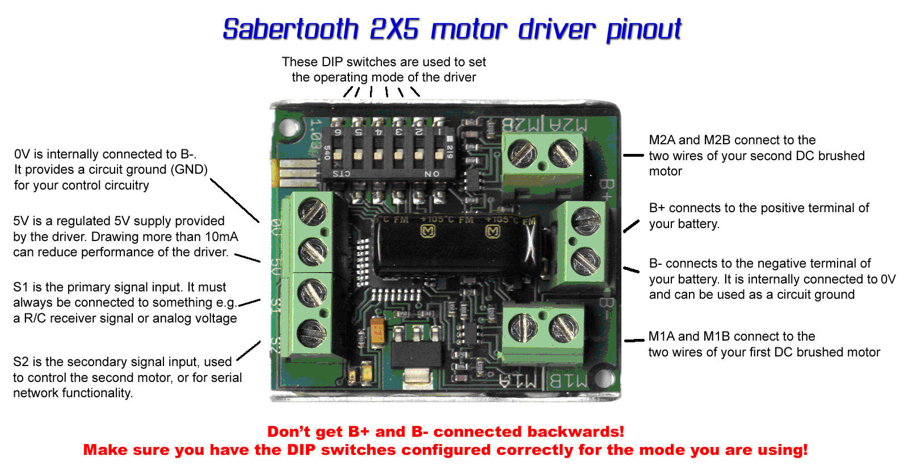 | Specs:
Input voltage:
6V-18V

Output current:
5A

Peak Output current:
10A

Operating modes:
Analog, R/C, Serial
For full product documentation and manual, please visit http://www.dimensionengineering.com/Sabertooth2X5.htm

Sabertooth 2X5
Operating mode quick reference chart All options are set via the switches
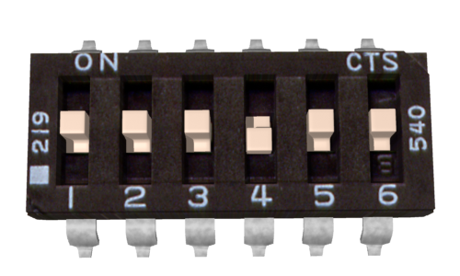 | Analog control, linear, independent: a 0V to 5V analog input is connected to terminals S1 and S2. 0V is full reverse, 5V is full forward, 2.5V is stop.
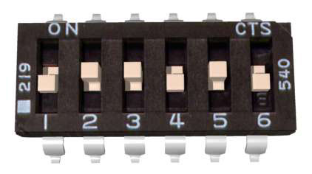 | Microcontroller pulses, independent linear control: An R/C servo signal is connected to terminals S1 and S2. A 1000us – 2000us pulse controls speed and direction. 1500us is stop.
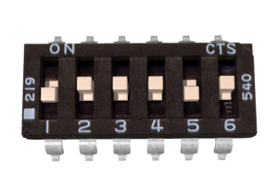 | Radio control, differential drive, exponential: An R/C servo signal is connected to terminals S1 and S2. The Sabertooth will autocalibrate the center and endpoints of the signal.
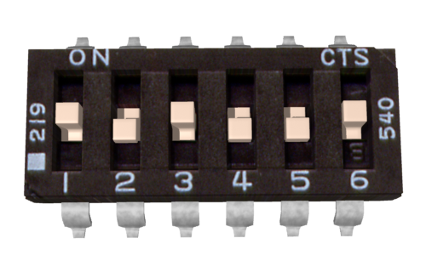 | Simplified Serial, 38400 Baud: A TTL level 8N1 serial data stream is connected to terminal S1. Control is with single byte commands.  Motor 1: 1 is full reverse, 64 is stop and 127 is full forward.  Motor 2: 128 is full reverse, 192 is stop and 255 is full forward.
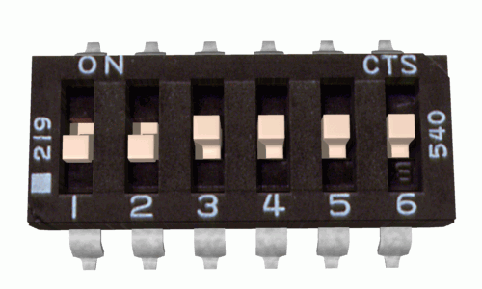 | Packetized Serial, address 128: A TTL level 8N1 serial data stream is connected to terminal S1. Control is via a multi-byte packet.
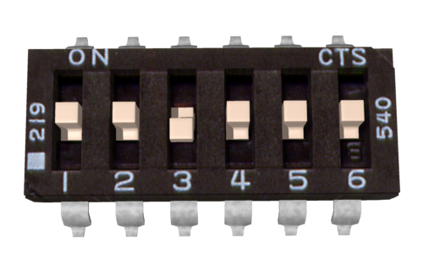 | Lithium cutoff option: When switch 3 is in the down position (in any operating mode) the Sabertooth will shut down at 3.0V per cell. This protects lithium batteries from damage.
Sabertooth features many more operating modes and options not shown here. For the full manual, please visit http://www.dimensionengineering.com/

