

SmartBEC installation guide
August 2005

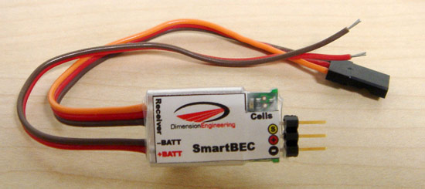

Introduction:

The SmartBEC is a switch-mode BEC with integrated lithium cutoff. It is designed to allow you to use older, but still perfectly good ESCs with modern lithium batteries – at up to 8s (33.6v) if the speed control will support it. The SmartBEC weighs only 6.8 grams, light enough to use in nearly any plane or small helicopter. It will power up to four standard servos or six sub-micro types. SmartBEC works with lithium packs from 3s to 8s. SmartBEC auto-detects the number of cells connected and displays this information by flashing the number of cells on the LED marked “Cells”. As a safety precaution, SmartBEC will not arm the ESC for pack voltages below 9v or above 33.6v.
Installation Instructions:

Step 1:
Connect the brown and red wires labeled +BATT and –BATT to the positive and negative input wires of your ESC. It is usually most convenient to attach the wires at the connector as shown.
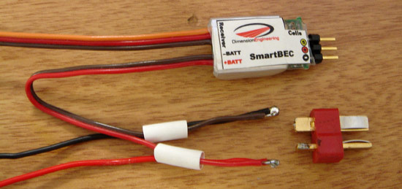

Step 2:
Plug the radio connector of your ESC into the port on the SmartBEC in the proper polarity. Depending on your brand of ESC, the signal wire that connects to the pin marked with the yellow-circled ‘S’ may be yellow, white or orange. By plugging the ESC into the SmartBEC, the BEC function of the ESC is bypassed and no further modification of the ESC is necessary. This arrangement also allows the SmartBEC to modify the throttle commands sent to the ESC if it is in low voltage cutoff mode.
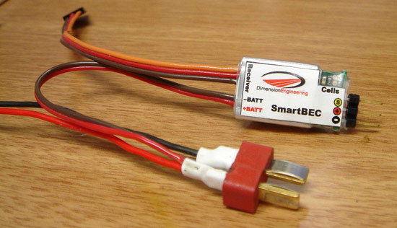

Step 3:
Plug the radio connector of the SmartBEC into the throttle port of your receiver.
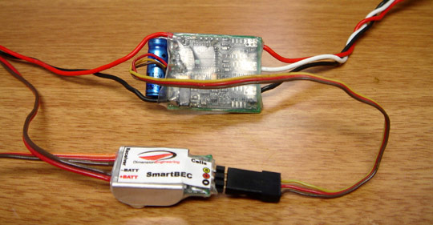

Step 4:
Secure the SmartBEC to the airframe with Velcro, double sided tape or rubber bands. Verify ESC and servo functionality before your first flight. To minimize the possibility of interference, please ensure that the SmartBEC is installed at least two inches (5cm) away from the receiver.

Step 5:
Before each flight, after connecting the battery, count the number of flashes displayed by the green LED labeled “Cells.” The light will flash the detected number of series cells in the pack. If the light should display less than the correct number, then the battery is in a discharged state. DO NOT fly until you have charged the battery and the SmartBEC has detected the correct number of cells.

In Flight:
The SmartBEC is a soft type lithium cutoff. This means that when your battery is nearly discharged, you will gradually lose power. It isn’t difficult to tell when you’re in cutoff if you know what to look for. If you fail to notice, though, you might have to make a long walk to your emergency landing site. The SmartBEC’s LVC works by scaling the throttle input to prevent discharge of the battery below 3V per cell. In flight, what you will notice initially is that going to full throttle doesn’t result in an increase in power over 3/4ths throttle. Depending on your battery and motor combination, you may hear a “growling” noise from your motor when the LVC is active. This is normal. If you continue to fly once your battery is nearly discharged, more and more of the throttle stick will fail to respond. Eventually the motor will shut down completely. The radio gear will continue to operate. Running the radio gear for long periods of time after the motor has cut out completely may over-discharge and damage the flight battery, and so is discouraged.

Recommended setups:

The SmartBEC is designed to supply up to 1.25 amps continuously and 1.5A for 60 seconds peak to the servos. The amount of current drawn by the servos varies considerably between airplanes and flying styles. A 100mph EDF will likely draw much more current than a floater. For high performance setups, please use a Dimension Engineering ServoSense to measure the in-flight average and peak current draw of your system. The following are provided as general guidelines.

Servo Type | Max number of servos
6g servos (HS-50, GWS Pico,etc.) | 6
9g servos (HS-55, GWS naro, etc.) | 6
“micro” servos (HS-81, GWS park) | 4
“Standard” servos | 4

