

SportBEC installation guide
November 2007

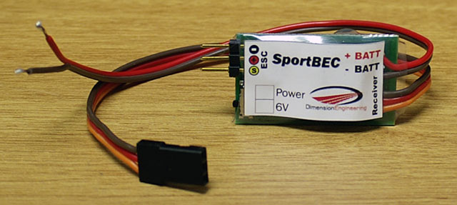

Introduction:

SportBEC is a switch-mode BEC specifically designed for sport planes, glow conversions, helicopters and more. It is designed for use with flight batteries from three to eight lithium cells, or up to 21 Nickel cells. The generous 3.5A current rating ensures a large safety margin when powering multiple servos. The product incorporates a throttle pass-through feature, which allows you to simply plug it in and go, without having to modify your ESC. SportBEC is designed for use with ESCs that are already lithium-aware and have the proper cutoff voltage.

Installation Instructions:

Step 1:
Connect the brown and red wires labeled +BATT and –BATT to the positive and negative input wires of your ESC. It is usually most convenient to attach the wires at the battery connector as shown. When you do this, you are putting SportBEC’s power wires in parallel with your ESC’s power wires.
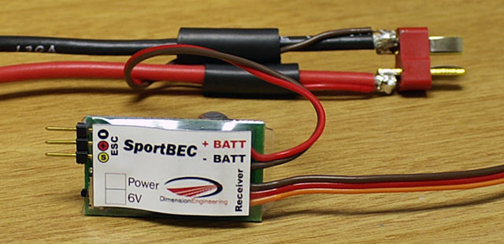

It is good practice to seal the battery connections with heatshrink tubing.
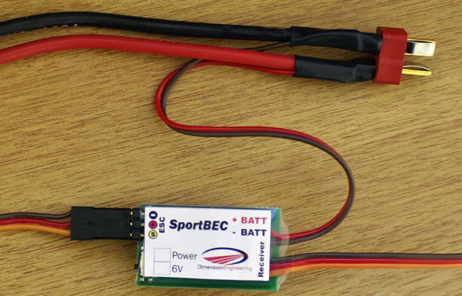

Step 2:
Plug the radio connector of your ESC into the port on the SportBEC in the proper polarity. Depending on your brand of ESC, the signal wire that connects to the pin marked with the yellow-circled ‘S’ may be yellow, white or orange. By plugging the ESC into the SportBEC, the BEC function of the ESC is disabled and no further modification of the ESC is necessary. This will not affect the ESC’s low voltage cutoff or any other ESC function because SportBEC passes the throttle signal straight through.
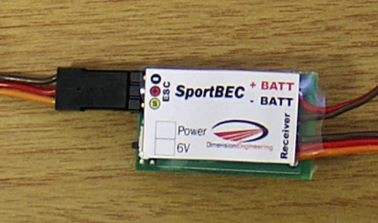

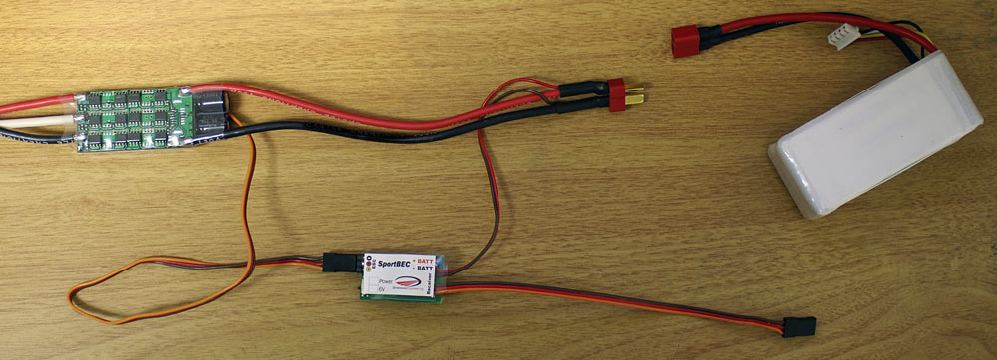

Step 3:
Plug the radio connector of the SportBEC into the throttle port of your receiver (usually channel 3).
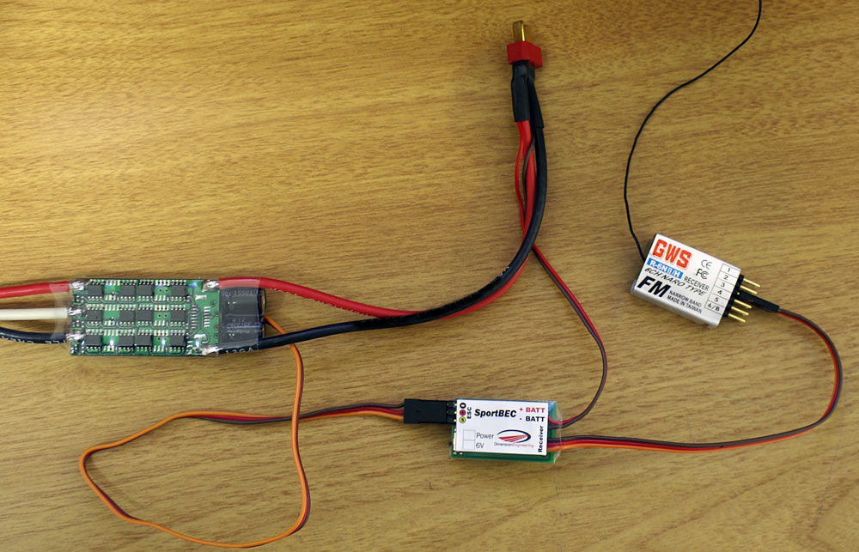

Step 4:
Secure the SportBEC to the airframe with Velcro, double sided tape or rubber bands. Verify ESC and servo functionality before your first flight. For best results, ensure that the SportBEC is installed at least 2-3 inches away from your receiver. Ideally you want the unit mounted in a spacious area, with lots of airflow around it to ensure good cooling, similar to how you would mount your ESC. This completes the installation of the SportBEC.
Updated instructions for opto-isolated speed controls, or speed controls without BECs:
The installation procedure for SportBEC is slightly different if you have an opto-isolated speed control, or if your speed control does not have a built in BEC. This design style is common with Jeti ESCs, and high voltage Castle ESCs. If you are having trouble identifying whether your speed control has a BEC or not please contact Dimension Engineering and we can help. A speed control without a BEC expects to be receiving power from the receiver to power its internal electronics. Here is how to do it:

Step 1:
Solder SportBEC’s battery wires in parallel with your battery connector, with the correct polarity.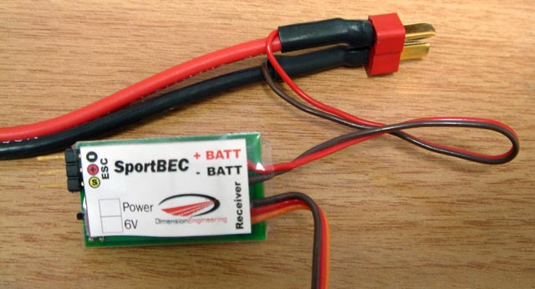

Step 2:
Plug your speed control’s pigtail into the throttle port of your receiver as normal.
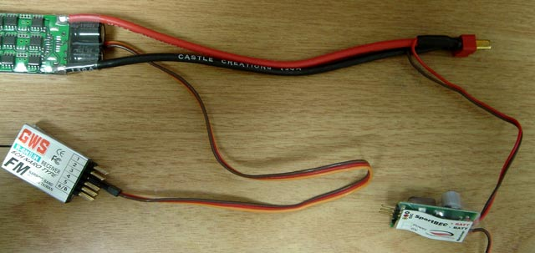
Step 3:
Plug SportBEC’s pigtail into the battery port of your receiver, or any other empty channel.
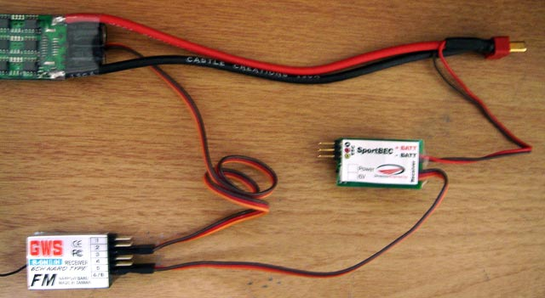

Optional step 4:
If you want, you can put a small piece of tape to cover SportBEC’s exposed pins but this is purely optional.
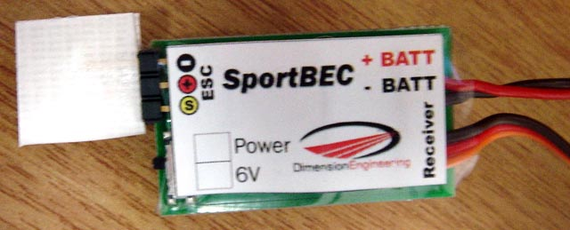
Step 5:
Secure the SportBEC to the airframe with Velcro, double sided tape or rubber bands. Verify ESC and servo functionality before your first flight. For best results, ensure that the SportBEC is installed at least 2-3 inches away from your receiver. Ideally you want the unit mounted in a spacious area, with lots of airflow around it to ensure good cooling, similar to how you would mount your ESC. This completes the installation of the SportBEC.

Recommended setups:

SportBEC is designed to supply up to 3.5 amps. Generally speaking, this is enough to handle the vast majority of servo setups, as long as you are not flying giant scale aircraft.
The following are provided as preliminary guidelines.

Servo Type | Max number of servos
6g servos (HS-50, GWS Pico,etc.) | 14
9g servos (HS-55, GWS naro, etc.) | 12
“micro” servos (HS-81, GWS park) | 8
“Standard” analog servos | 8
Smaller digital servos (DS285, DS368) | 6-8
High speed/torque digital servos (HS-5625) | 4-6

