
SyRen 25 Quick Start Guide
July 2007

Congratulations on your purchase of a Syren 25 regenerative motor driver. SyRen 25 is one of the most flexible and configurable motor drivers on the market. As a result, it must be set to the correct operating mode before use before use. Below is a generalized hookup diagram of a Syren 25. On the reverse side is a chart of some of the most commonly used operating modes.
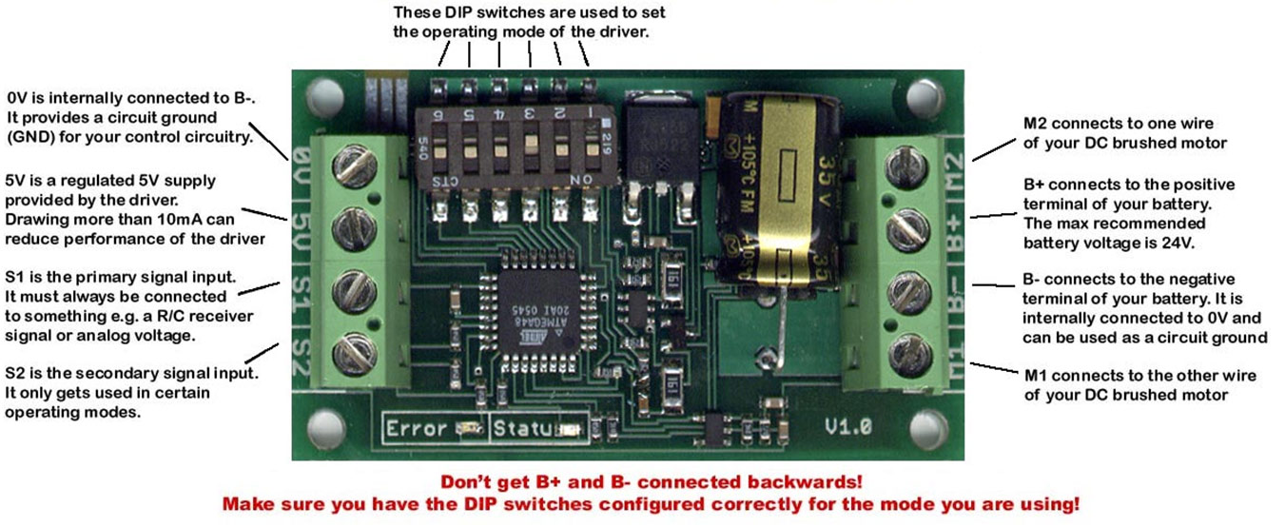 | SyRen 25
Input voltage:
6V-24V

Output current:
25A

Peak Output current:
45A

Operating modes:
Analog, R/C, Serial
For full product documentation and manual, please visit http://www.dimensionengineering.com/SyRen25.htm

SyRen 25
Operating mode reference chart. All options are set via the DIP switches
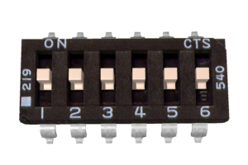 | Analog bi-direction: a 0V to 5V analog input is connected to terminal S1. 0V is full reverse, 5V is full forward and 2.5V is stop
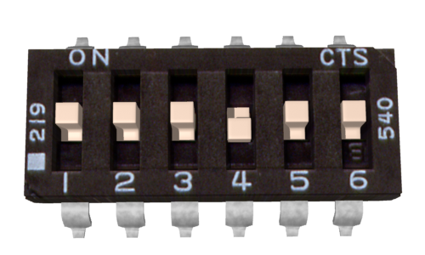 | Analog single-direction: a 0V to 5V analog input is connected to terminal S1. 0V is stop and 5V is full forward.
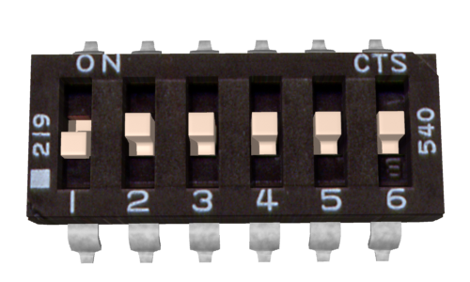 | R/C standard: An R/C servo signal is connected to terminal S1. A 1000us pulse is full reverse and a 2000us pulse is full forward. 1500us is stop.
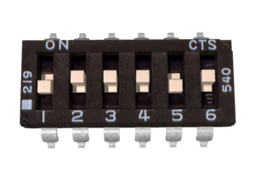 | R/C auto-calibrate: An R/C servo signal is connected to terminal S1. The SyRen will automatically detect the center and endpoints of the signal.
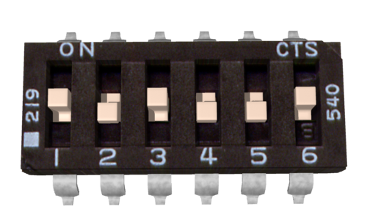 | Simplified Serial, 38400 Baud: A TTL level 8N1 serial data stream is connected to terminal S1. Control is by single byte commands: 0 is full reverse, 128 is stop and 255 is full forward.
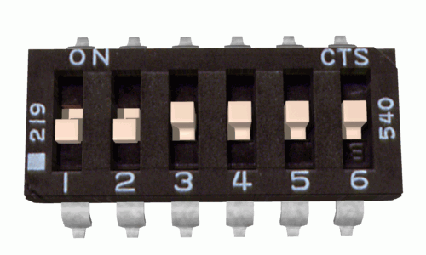 | Packetized Serial, address 128: A TTL level 8N1 serial data stream is connected to terminal S1. Control is via a multi-byte packet.
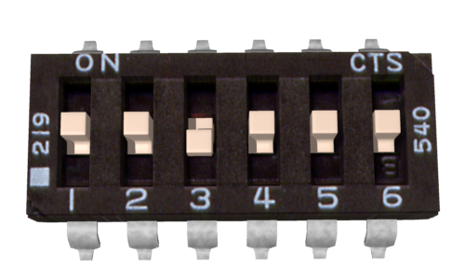 | Lithium cutoff option: When switch 3 is in the down position (in any operating mode) the SyRen will shut down at 3.0V per cell. This protects lithium batteries from damage.
SyRen 25 features an additional 17 operating modes and options not shown here. For the full manual, please visit http://www.dimensionengineering.com/SyRen25.htm

