
SyRen 50 Quick Start Guide
April 2011

Congratulations on your purchase of a SyRen 50 regenerative motor driver. SyRen 50 is one of the most flexible and configurable motor drivers on the market. As a result, it must be set to the correct operating mode before use. Below is a generalized hookup diagram of a SyRen 50. On the reverse side is a chart of some of the most commonly used operating modes.
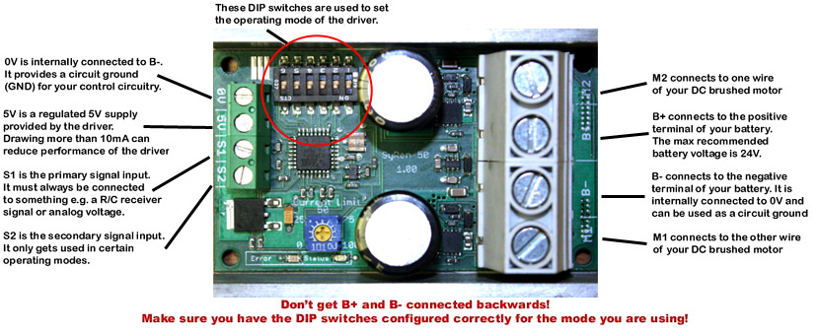 | SyRen 50
Input voltage:
6V-24V

Output current:
50A

Peak Output current:
100A

Operating modes:
Analog, R/C, Serial
For full product documentation and manual, please visit http://www.dimensionengineering.com/SyRen50.htm

Operating mode reference chart. All options are set via the DIP switches
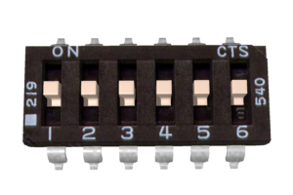 | Analog bi-direction: a 0V to 5V analog input is connected to terminal S1. 0V is full reverse, 5V is full forward and 2.5V is stop
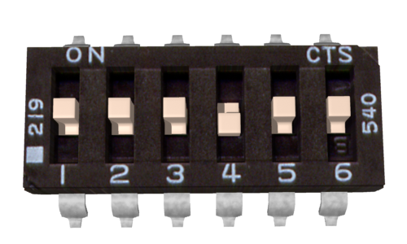 | Analog single-direction: a 0V to 5V analog input is connected to terminal S1. 0V is stop and 5V is full forward.
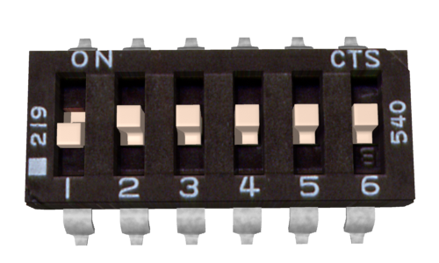 | R/C standard: An R/C servo signal is connected to terminal S1. A 1000us pulse is full reverse and a 2000us pulse is full forward. 1500us is stop.
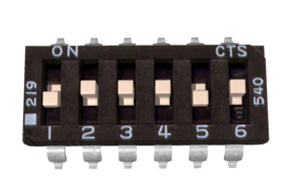 | R/C auto-calibrate: An R/C servo signal is connected to terminal S1. The SyRen will automatically detect the center and endpoints of the signal.
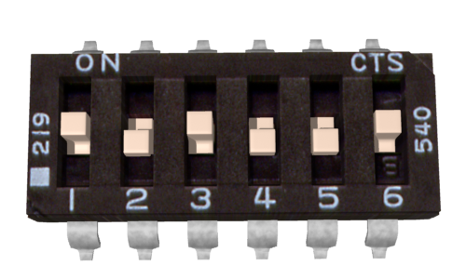 | Simplified Serial, 38400 Baud: A TTL level 8N1 serial data stream is connected to terminal S1. Control is by single byte commands: 0 is full reverse, 128 is stop and 255 is full forward.
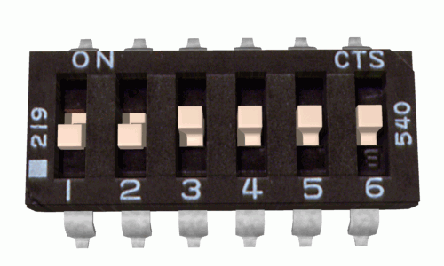 | Packetized Serial, address 128: A TTL level 8N1 serial data stream is connected to terminal S1. Control is via a multi-byte packet.
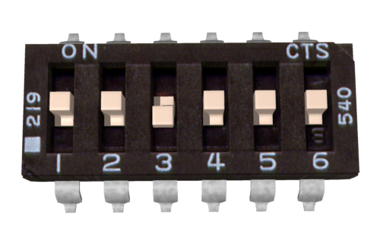 | Lithium cutoff option: When switch 3 is in the down position (in any operating mode) the SyRen will shut down at 3.0V per cell. This protects lithium batteries from damage.
SyRen 50 features an additional 20+ operating modes and options not shown here. For the full manual, please visit http://www.dimensionengineering.com/SyRen50.htm

