

VHVBEC installation guide
November 2007

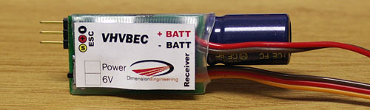

Introduction:

VHVBEC is a switch-mode BEC specifically designed for very high voltage helicopters and more. It is designed for use with flight batteries from three to fourteen lithium cells, or up to 40 Nickel cells. The 2.5A current rating is valid across VHVBEC’s entire input voltage range, allowing it to safely power multiple servos. The product incorporates a throttle pass-through feature, which allows you to simply plug it in and go without having to modify your ESC. VHVBEC is designed for use with ESCs that are already lithium-aware and have the proper cutoff voltage.

Installation Instructions:

Connect the brown and red wires labeled +BATT and –BATT to the positive and negative input wires of your ESC. It is usually most convenient to attach the wires at the battery connector as shown. When you do this, you are putting VHVBEC’s power wires in parallel with your ESC’s power wires. This way, VHVBEC can convert the battery pack’s voltage into the 5V or 6V your receiver and servos need.
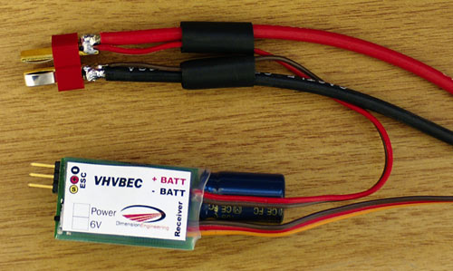

It is good practice to seal the battery connections with heatshrink tubing.
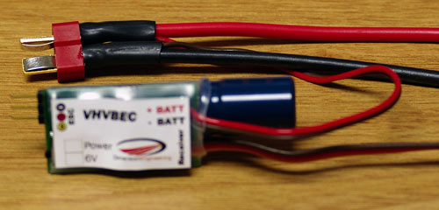

Important!

There are two different ways to perform the rest of VHVBEC’s installation. The method you should use will depend on the type of speed control you have.

If you have a standard speed control that does not have an opto-isolated design, you should use VHVBEC’s throttle pass-through feature. It will automatically disable your ESC’s BEC.

If your speed control is optoisolated, or if your speed control does not have a BEC, the throttle pass-through feature won’t work for you. You should use the alternate method.

If you don’t know whether your ESC is opto-isolated or not, then you should use the “standard” installation method first to be on the safe side. If you find that the speed control does not behave properly with the standard installation method, then you can try the opto-isolated method and it should work.
Installation method for “standard” (non-optoisolated) speed controls with a built in BEC:
Plug the radio connector of your ESC into the port on the VHVBEC in the proper polarity. Depending on your brand of ESC, the signal wire that connects to the pin marked with the yellow-circled ‘S’ may be yellow, white or orange. By plugging the ESC into the VHVBEC, the BEC function of the ESC is disabled and no further modification of the ESC is necessary. This will not affect the ESC’s low voltage cutoff or any other ESC function because VHVBEC passes the throttle signal straight through.
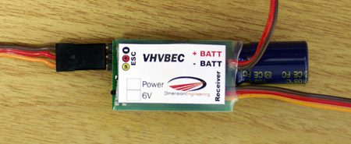

Since the throttle signal passes straight through VHVBEC now, you can just insert VHVBEC’s pigtail into the throttle port of your receiver – usually CH3.
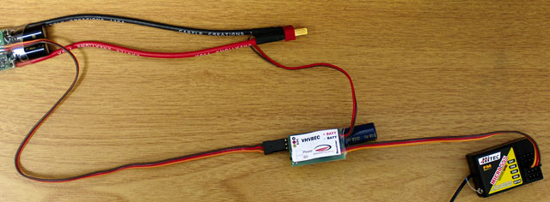
Installation method for opto-isolated speed controls, or speed controls without a BEC:
An opto isolated ESC expects to receive power from the receiver. In order to accomplish this, plug your ESC’s pigtail into your receiver’s throttle port as normal - usually CH3. Next, plug VHVBEC’s pigtail into your receiver’s BATT port. You could also plug it into CH6, CH7, or any other channel that happens to be unused. When you do this, the regulated voltage coming out of VHVBEC can flow through the receiver and reach your ESC.
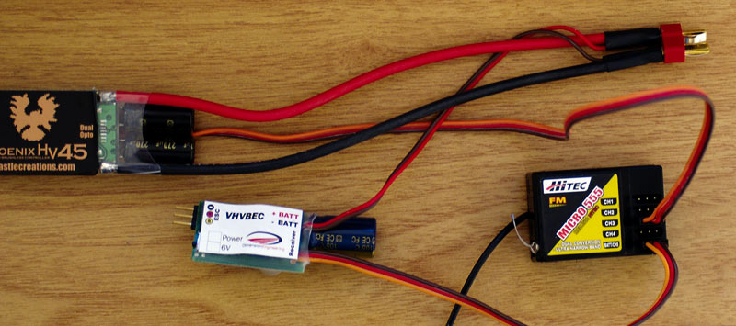

Secure the VHVBEC to the airframe with Velcro, double sided tape or rubber bands. Verify ESC and servo functionality before your first flight. For best results, ensure that the VHVBEC is installed at least 2-3 inches away from your receiver. Ideally you want the unit mounted in a spacious area, with lots of airflow around it to ensure good cooling, similar to how you would mount your ESC. Use the slide switch to toggle between 5V and 6V as you wish. This completes the installation of the VHVBEC.

Recommended setups:

VHVBEC is designed to supply up to 2.5 amps. This should be enough for nearly any helicopter running 4 servos. The following are provided as approximate guidelines to what you can power with a VHVBEC:

Servo Type | Max number of servos
6g servos (HS-50, GWS Pico,etc.) | 10
9g servos (HS-55, GWS naro, etc.) | 8
“micro” servos (HS-81, GWS park) | 6
“Standard” analog servos | 6
Smaller digital servos (DS285, DS368) | 4-5
High speed/torque digital servos (HS-5625) | 4

